**SRI VASAVI ENGINEERING COLLEGE (Autonomous)**

**PEDATADEPALLI, TADEPALLIGUDEM-534 101**

**Department of Computer Science and Engineering (Accredited By NBA)**

|  |
| --- |
|  |

**COMPUTER ENGINEERING WORKSHOP**

**V20 LAB MANUAL**

**2021-22**

**TASK-1**

**Identifying the Peripherals of a Computer**

Identify the peripherals of a computer, components in a CPU and its functions. Draw the block diagram of the CPU along with the configuration of each peripheral and submit to your instructor.

**AIM:** To identify the peripherals of a computer.

**In this section you will know about Internal components of the computer**

* The Mother Board
* CPU
* SMPS
* Cabinet
* CPU Heat Sink & Fan
* RAM
* Hard Disk Drive (HDD)
* Floppy Disk Drive (FDD)

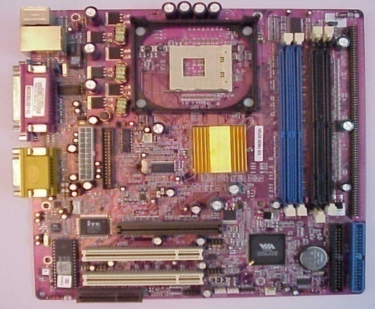

The motherboard serves as a single platform to connect all of the parts of a computer together. It connects the CPU, memory, hard drives, optical drives, video card, sound card, and other ports and expansion cards directly or via cables. It can be considered as the backbone of a computer.

**CPU(Central Processing Unit)**

* Central Processing Unit (CPU) consists of the following features −
* CPU is considered as the brain of the computer.
* CPU performs all types of data processing operations.
* It stores data, intermediate results, and instructions (program).
* It controls the operation of all parts of the computer.

**CPU itself has following three components.**

* Memory or Storage Unit
* Control Unit
* ALU(Arithmetic Logic Unit)
* **Memory or Storage Unit**

This unit can store instructions, data, and intermediate results. This unit supplies information to other units of the computer when needed. It is also known as internal storage unit or the main memory or the primary storage or Random Access Memory (RAM).

* **Control Unit**

This unit controls the operations of all parts of the computer but does not carry out any actual data processing operations.

* **ALU (Arithmetic Logic Unit)**

Function of arithmetic logic unit is to perform arithmetic and logic operations like addition, subtraction, multiplication, division comparing, selecting etc.

**Switched-Mode Power Supply (SMPS)**

A switched-mode power supply (SMPS) is an electronic circuit in a computer, it is used to supply power to all the electronic component of computer by converting AC power into the low voltage DC supply.

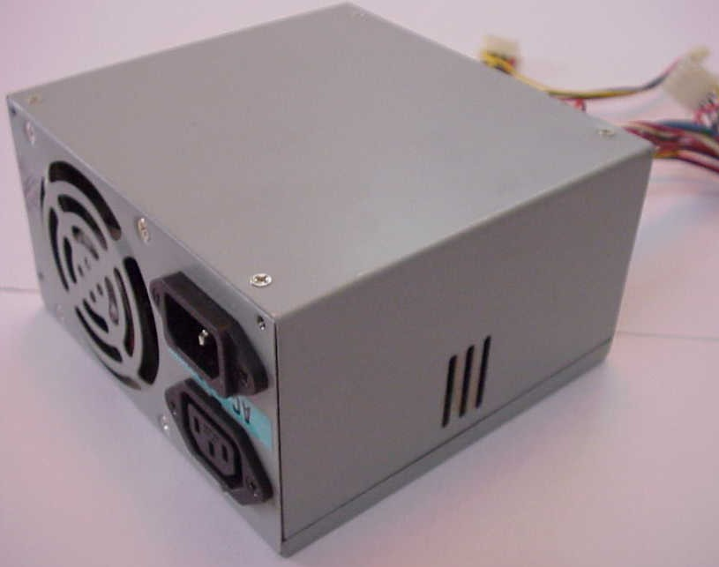

**Computer Cabinet**

A computer cabinet is an enclosure with fitted, fixed or removable side panels and doors. The cabinet contains a computer rack for mounting computers or other electronic equipment. Cabinets come in a variety of sizes, colors and styles

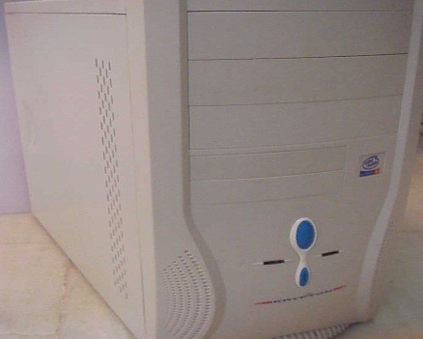

**CPU Heat Sink & Fan**

* Computer cooling is required to remove the [waste heat](https://en.wikipedia.org/wiki/Waste_heat) produced by [computer components](https://en.wikipedia.org/wiki/Computer_components).
* [heatsink](https://en.wikipedia.org/wiki/Heatsink) with fan clipped onto a microprocessor. [heatsinks](https://en.wikipedia.org/wiki/Heat_sink) cooled by airflow with  [Computer fans](https://en.wikipedia.org/wiki/Computer_fan) reduces the temperature by actively exhausting hot air.

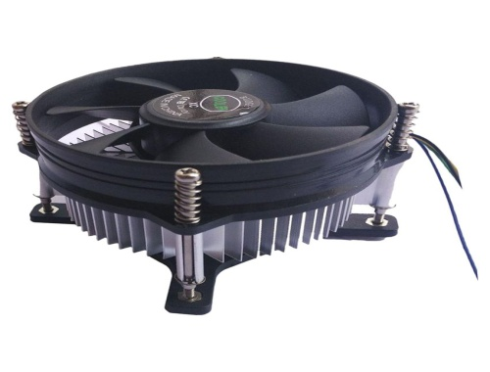

**RAM**

* RAM (Random Access Memory) is the internal memory of the CPU for storing data, program, and program result. It is a read/write memory which stores data until the machine is working. As soon as the machine is switched off, data is erased.
* The most common types of RAM are [SDRAM](https://www.computerhope.com/jargon/s/sdram.htm) and [DDR](https://www.computerhope.com/jargon/d/ddr.htm) for desktop computers and [SODIMM](https://www.computerhope.com/jargon/d/dimm.htm) for [laptop](https://www.computerhope.com/jargon/l/laptop.htm) computers,

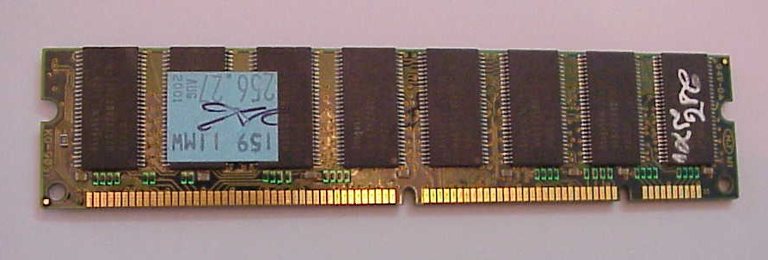

**Computer - Read Only Memory**

ROM stands for **Read Only Memory**. The memory from which we can only read but cannot write on it. This type of memory is non-volatile. The information is stored permanently in such memories during manufacture. A ROM stores such instructions that are required to start a computer.

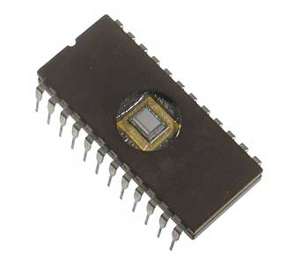

Following different types of ROM are as follows:-

**MROM (Masked ROM):-**The very first ROMs, that contained a pre-programmed set of data or instructions.

**PROM (Programmable Read Only Memory):-**PROM is read-only memory that can be modified only once by a user. The user buys a blank PROM and enters the desired contents using a PROM program.

**EPROM (Erasable and Programmable Read Only Memory):-**EPROM can be erased by exposing it to ultra-violet light for a duration of up to 40 minutes. During programming, an electrical charge is trapped in an insulated gate region.

**EEPROM (Electrically Erasable and Programmable Read Only Memory):-**EEPROM is programmed and erased electrically. It can be erased and reprogrammed about ten thousand times.

**Hard Disk Drive (HDD)**

* A non-volatile storage device used to store digital data on magnetic surface of rigid plate by using read/write heads.
* **Description**
* It is secondary storage device. Used to store programs and large data files.
* Standard size is 3.5 inch for desktops and 2.5 inch for laptops

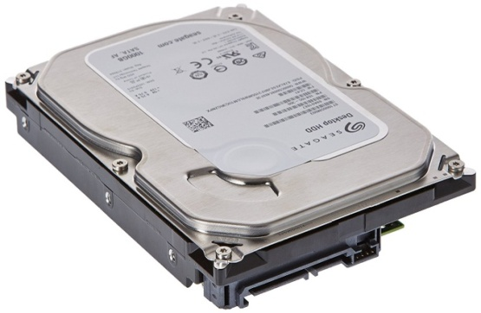

**Solid State Drive (SSD)**

A **solid-state drive** (SSD) is a new generation of storage device used in computers. SSDs use flash-based memory, which is much faster than a traditional mechanical hard disk. Upgrading to an SSD is one of the best ways to speed up your computer.

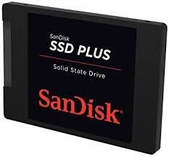

**Floppy Disk Drive (FDD)**

The floppy drive is a piece of [computer hardware](https://www.lifewire.com/computer-hardware-2625895) that reads data from, and writes data to, a computer.

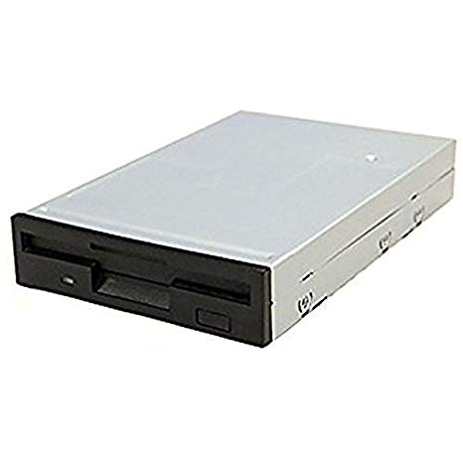

**DVD WRITER**

A DVD [writer](https://www.collinsdictionary.com/dictionary/english/writer) is a piece of computer [equipment](https://www.collinsdictionary.com/dictionary/english/equipment) that we use for [copying](https://www.collinsdictionary.com/dictionary/english/copying) [data](https://www.collinsdictionary.com/dictionary/english/datum) from a computer onto a CD.

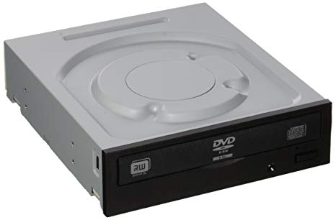

**LAN(Local Area Network):**

LAN cards are hardware devices that can be added to a computer, LAN card is a physical interface through which the LAN cable plugs into the computer, and is also used to provide a data link. It is used to sending and receiving of network data.

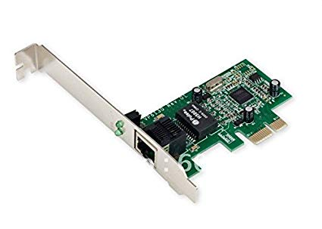

**CMOS Battery**

The [CMOS](https://www.computer-hardware-explained.com/cmos.html) is a little bit of [RAM](https://www.computer-hardware-explained.com/computer-ram.html) that stores all the [BIOS](https://www.computer-hardware-explained.com/computer-bios.html) information so that each time the computer restarts or powers on the computer can remember this information. There is a battery in the motherboard, which is used to power the south bridge and the BIOS to save the setting, data and time.

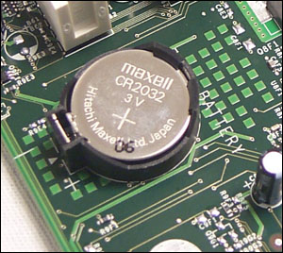

**ATX Power Connector**

ATX power connectors are designed to connect a computer’s power supply to an motherboard

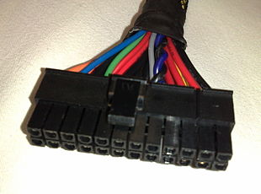

**Floppy Cable**

A **floppy cable** is a ribbon cable found in PC's that allow one or more floppy disk drives to be connected to a computer.

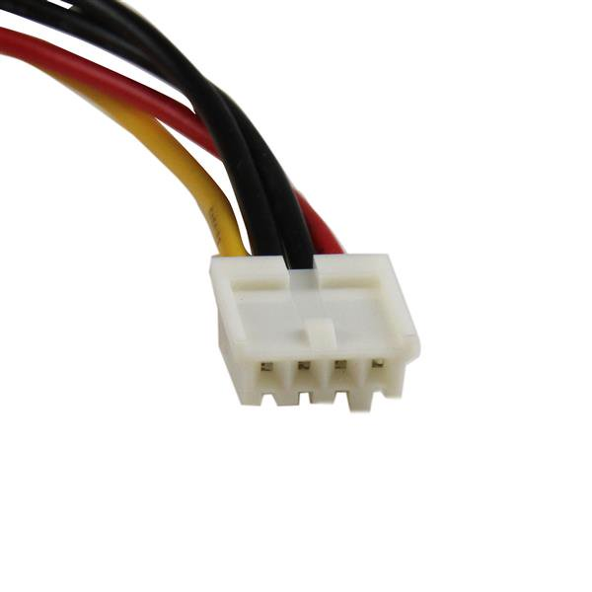

**Accelerated Graphics Port (AGP)**

Accelerated Graphics Port refers to the actual [expansion slot](https://www.lifewire.com/expansion-slot-2625870) on the [motherboard](https://www.lifewire.com/motherboards-system-boards-and-mainboards-2618154) that accepts AGP video cards. This slot is for graphics and 3d gaming purpose. it is always beside the PCI slots

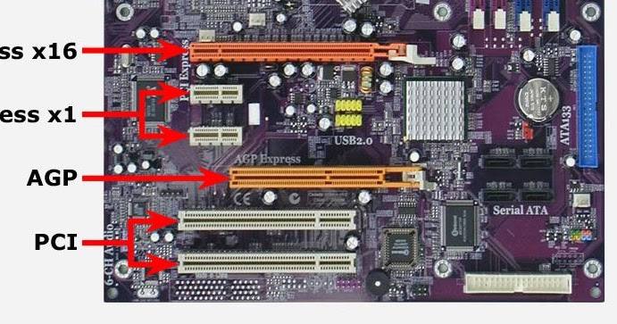

**PORT**

* Ports are used to connect input and output devices. they are attached and are available with motherboard and they are in backside of CPU.

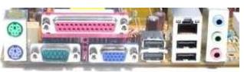

.

**PCI SLOT(Peripheral Component Interconnect)**

* PCI slots (and their variants) allow you to add expansion (Add-on) cards to a motherboard like sound card LAN card and TV tuner card.
* The expansion cards increase the machines capabilities beyond what the motherboard could produce alone, such as: enhanced graphics, expanded sound, increased USB and hard drive controller, and additional network interface options

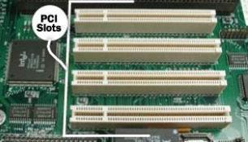

**BIOS (basic input/output system)**

BIOS (basic input/output system) is the program in a personal computer's [microprocessor](http://searchcio-midmarket.techtarget.com/definition/microprocessor),uses to get the computer system started after you turn it on. It also manages data flow between the computer's [operating system](http://searchcio-midmarket.techtarget.com/definition/operating-system) and attached devices such as the [hard disk](http://searchstorage.techtarget.com/definition/hard-disk),[video adapter](http://searchcio-midmarket.techtarget.com/definition/video-adapter), [keyboard](http://searchcio-midmarket.techtarget.com/definition/keyboard), [mouse](http://searchexchange.techtarget.com/definition/mouse) and [printer](http://whatis.techtarget.com/definition/printer).

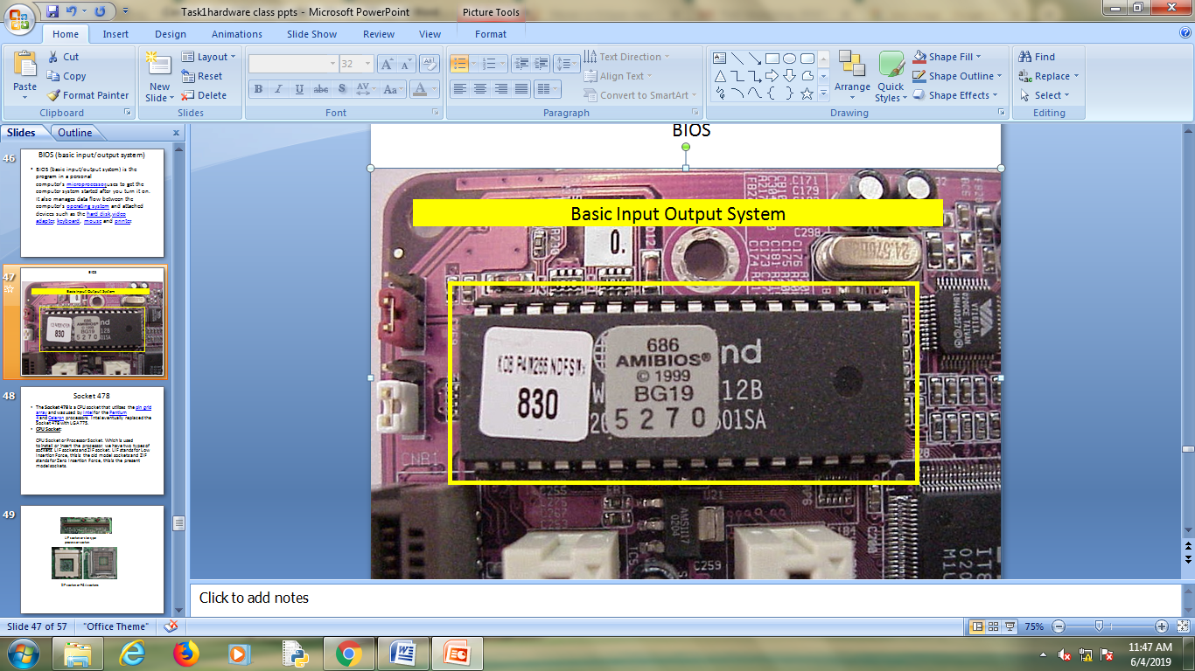

**Socket 478**

* The Socket 478 is a CPU socket that utilizes the [pin grid array](https://www.computerhope.com/jargon/p/pga.htm) and was used by [Intel](https://www.computerhope.com/comp/intel.htm) for the [Pentium 4](https://www.computerhope.com/jargon/p/pentium_4.htm) and [Celeron](https://www.computerhope.com/jargon/c/celeron.htm) processors. Intel eventually replaced the Socket 478 with LGA 775.

**CPU Socket:**

CPU Socket or Processor Socket. Which is used to install or insert the processor. We

have two types of sockets. LIF sockets and ZIF socket. LIF stands for Low Insertion Force, this is the old model sockets and ZIF stands for Zero Insertion Force, this is the present model sockets.

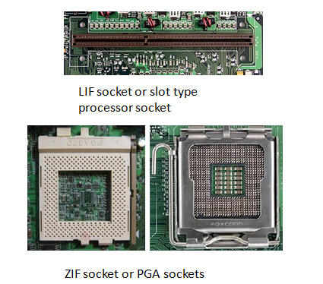

**RAM SLOTS**

A memory slot, memory socket, or RAM slot allows computer memory ([RAM](https://www.computerhope.com/jargon/r/ram.htm)) to be inserted into the computer. Depending on the [motherboard](https://www.computerhope.com/jargon/m/mothboar.htm), there may be two to four memory slots.

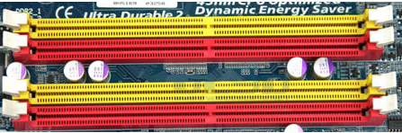

**SATA Connectors**

SATA connectors are also called as Serial ATA connectors. SATA full form is Serial Advanced Technology Attachment. These are connect with serial ATA devices, such as Hard disk drives and CD or DVD drives.

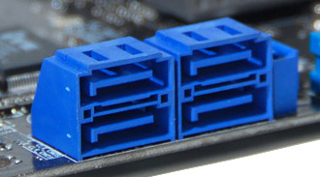

**North Bridge**:

North Bridge is always near the processor socket. which is one of the important component of a motherboard. It is a focal Point of Motherboard and It is also called as Memory Controller Hub. North Bridge interconnects Processor socket, RAM slots and AGP slot. Here Gigabyte chip is north bridge it is near Processor socket.

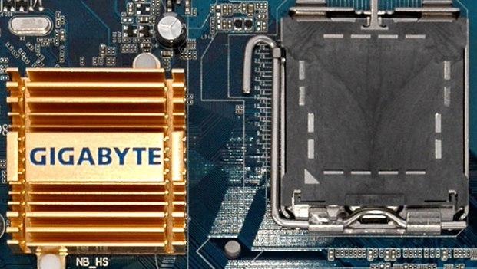

**South Bridge**

North bridge and south bridge are the two main poles of a motherboard. South Bridge interconnects Primary and Secondary IDE interfaces, SATA connectors, Floppy Drive Connector, PCI slots and BIOS.

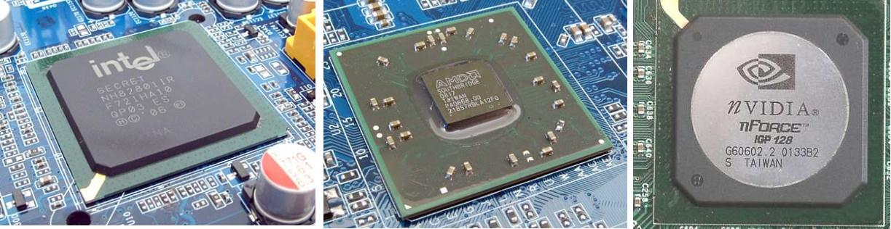

**TASK 2**

**DISASSEMBLE AND ASSEMBLE THE SYSTEM**

**AIM :** To disassemble and assemble the system

**Steps for Assembling :**

* Installing the Motherboard
* Installing the processor
* Installing the heat sink
* Installing the power supply
* Installing the video card
* Installing the hard disk
* Installing optical drive
* Connecting power to motherboard
* Connections of the output channel

**Getting the Cabinet ready :**

Check how to open the cabinet and determine where to fix the components. Determine if the case has appropriate risers installed.

**Steps for Assembling :**

* CPU
* Motherboard
* RAM
* Heat Sink / Cooler / Fan
* Ribbon cables
* CD-ROM Drive
* Network adapter drive
* Floppy disk drive
* Hard disk
* Screws

**Installing the Mother board :**

* Open the side doors of the cabinet
* Lay the cabinet on its side
* Put the motherboard in place
* Drive in all the required screws

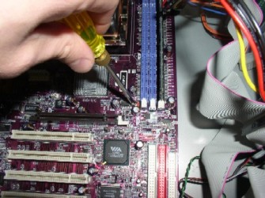

**Installing the Processor :**

* Lift the CPU lever on the motherboard
* Place the CPU properly on the motherboard
* Pull down the lever to secure the CPU in place

[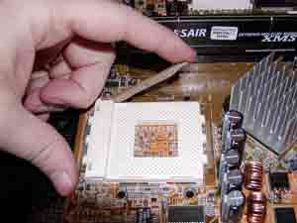](http://z.about.com/d/compreviews/1/0/0/3/DIY-CPU1.jpg)

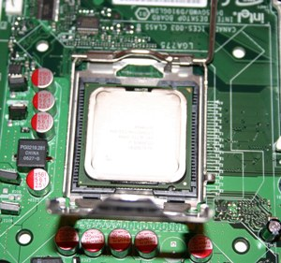

.

[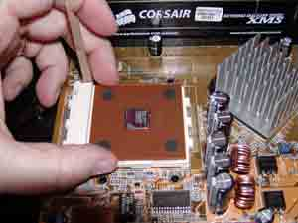](http://z.about.com/d/compreviews/1/0/w/2/DIY-CPU3.jpg)

[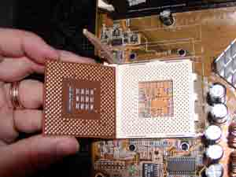](http://z.about.com/d/compreviews/1/0/y/2/DIY-CPU2.jpg)

**Installing the Heat sink :**

* Place the heat sink on the processor
* Put the jacks in place
* Secure the heat sink with the lever

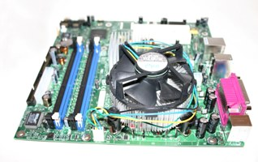

**Installing the RAM :**

* The RAM must be suitable for motherboard
* Push down the RAM into the slot
* Make sure both the clips hold the RAM properly

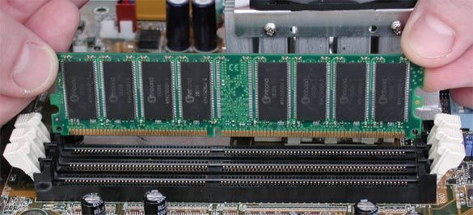

**Installing the power supply :**

* Place the SMPS into the cabinet
* Put the screws in place tightly

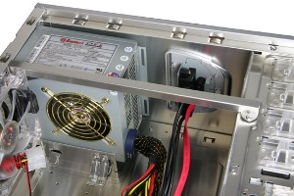

**Installing the video card :**

* Remove the back plate on the cabinet corresponding to the graphics card
* Push the card into the slot
* Secure the card with a screw
* Plug in the power connection from PSU (if required)

High-end graphics cards need dedicated power supply and if your graphics card needs one then connect the appropriate wire from PSU into the graphics card.

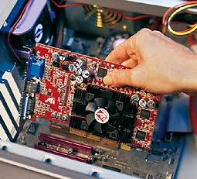

**Installing the hard disk :**

* Place the hard drive into the bay
* Secure the drive with screws
* Connect the power cable from PSU
* Connect the data cable from motherboard into the drive

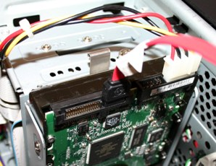

**Installing optical drive :**

* Place the optical drive into the bay
* Drive in the screws
* Connect the power cable and data cable

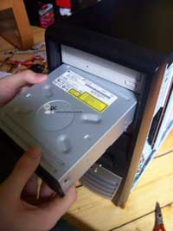 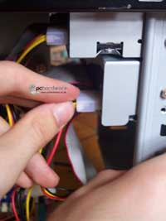

**Connecting power to motherboard :**

* Close the side doors of the cabinet and get it upright and place it on the computer table. Get the rest of the PC components like monitor, keyboard, mouse, speakers etc. which we will connect now.

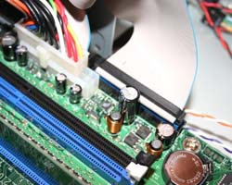

**Connections of the output channel :**

* If the mouse/ keyboard are PS/2 then connect them to PS/2 ports or else use the USB port.
* Connect the speaker cable in the audio port
* Plug in the power cable from PSU into the UPS
* Also plug in the power cable of the monitor

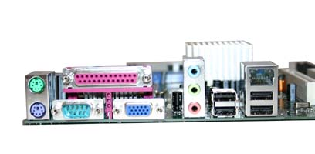

**Final Check :**

* Mother board jumper configurations are the settings for the processor operator.
* Drive jumper settings, master/ slave correct
* Are the processors, RAM modules and plug in cards finally seated in their sockets?
* Did you plug all the cables in? Do they all fit really
* Have you frightened all the screws in plug- in cards or fitted the clips
* Have u connected the power cables to all driver

**Powering up for the first time :**

* Ensure that no wires are touching the CPU heat sink fan.
* Plug in the monitor, mouse and keyboard.
* Plug in the power card and switch the power supply.
* If everything is connected as it should be

1. All system fans should start spinning.
2. We should hear a single beep sound after about 5-10 sec.
3. Amber light on monitor should go green.
4. We will see the computer start to boot with a memory check.
5. Now check front LED’s to see if u plugged them correctly.
6. Check all other buttons.
7. Power afford change any power settings

**TASK-3**

**MS –WINDOWS INSTALLATION**

In order to install your copy of the Windows 10 operating system please make sure to have the following items:

-Windows 10 Installation disk

-Drivers CD: * Use after installation process if needed.

\***NOTE:** Please make sure to back up all of your important data before proceeding with this installation.

**Step-1:** Connect the Bootable USB flash drive with your PC and reboot it.

**Step-2:** As soon as your PC boots, press the F11 ( this key will differ from one pc to another ) key to bring up the boot drive selection menu and select the Bootable Windows 10 USB flash drive. This key will differ from one pc to another, so do a quick Google search to find out the correct key to bring up the bios boot menu.

Alternatively, you can also go into the bios of your PC and set the Bootable Windows 10 USB flash drive with the **First boot priority**.

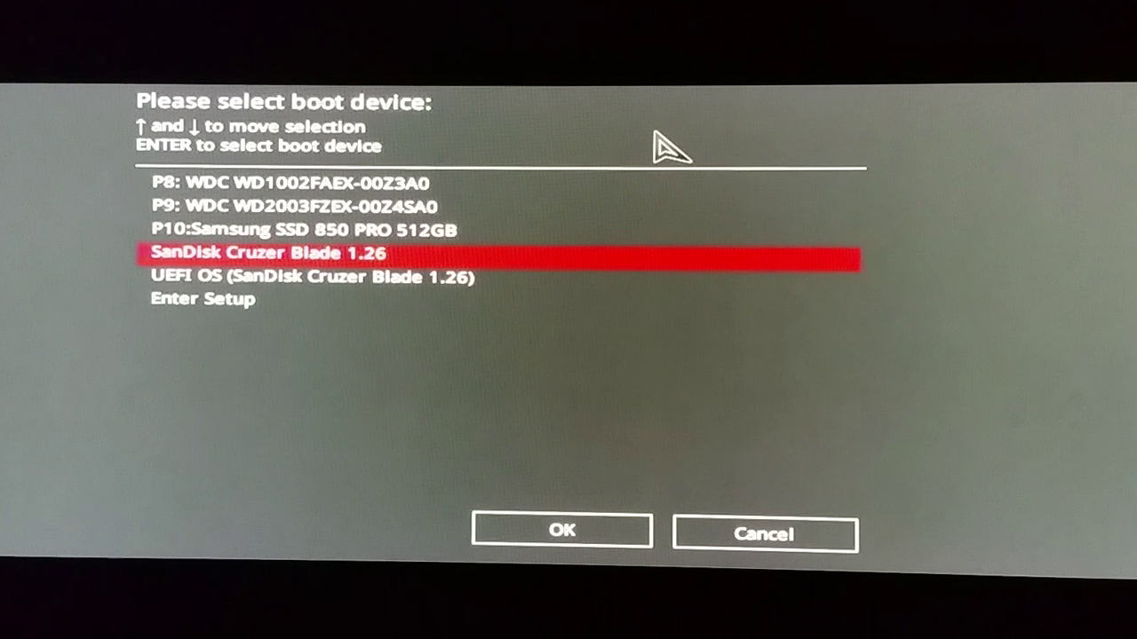

**Step-3:** Press any key when you see the “ **Press any key to boot from the USB option** ”

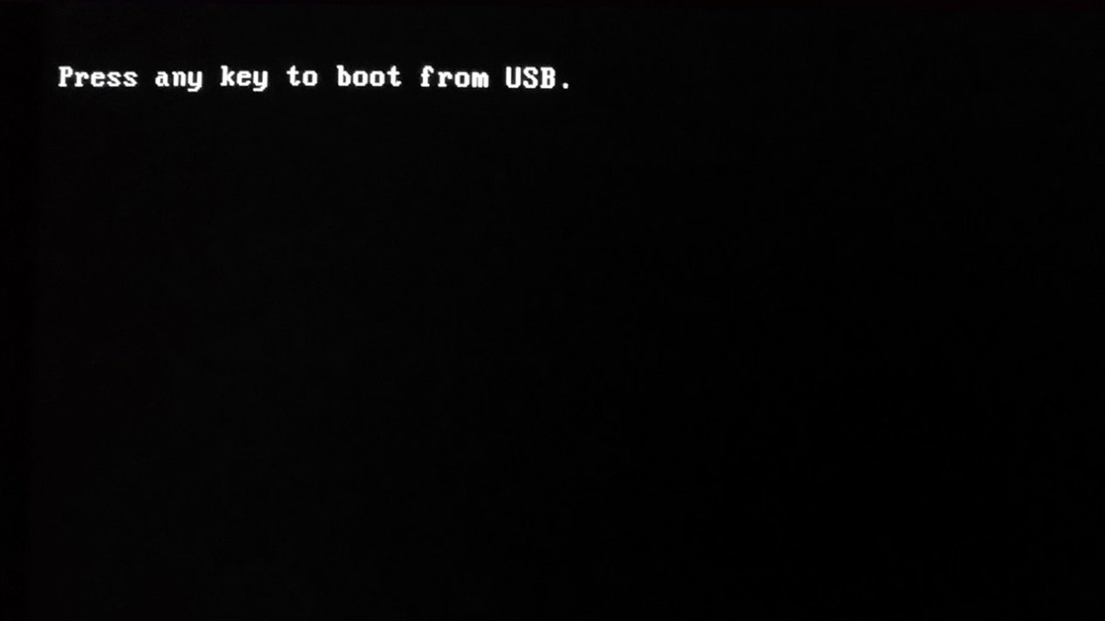

**Step-4:** Wait for a few seconds for the files to load.

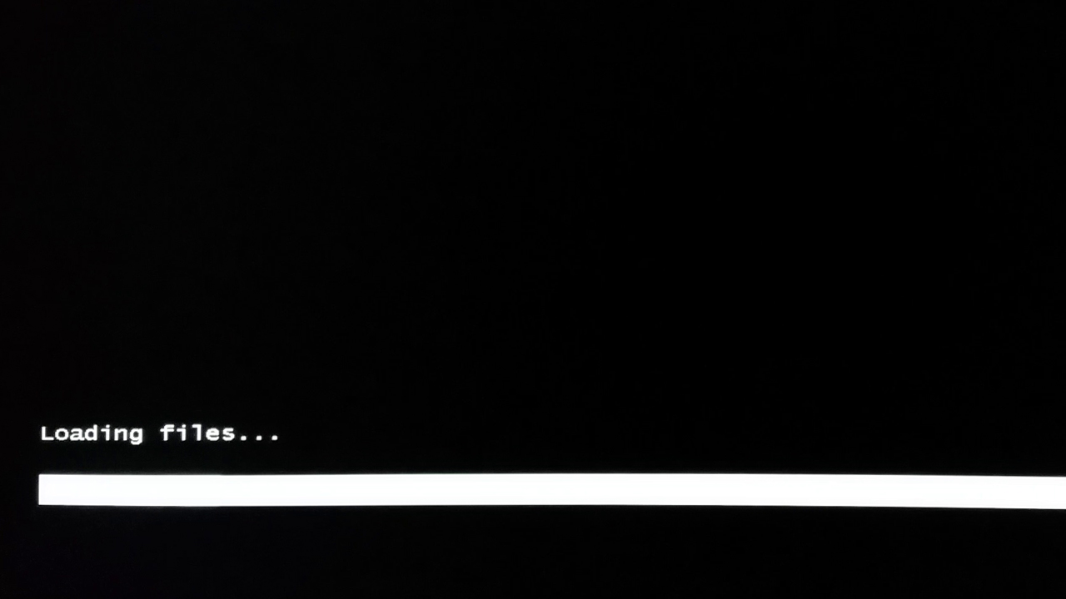

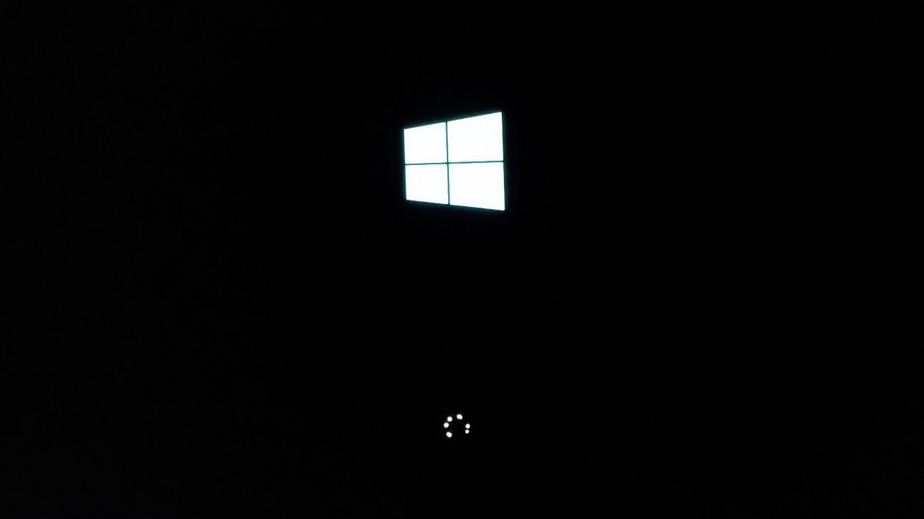

**Step-5:** On the Windows Setup page, select your language, time and keyboard preferences. Then select Next.

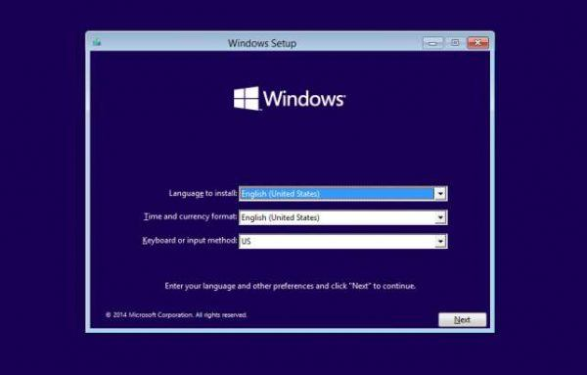

**Step-6:** Click on Install now.

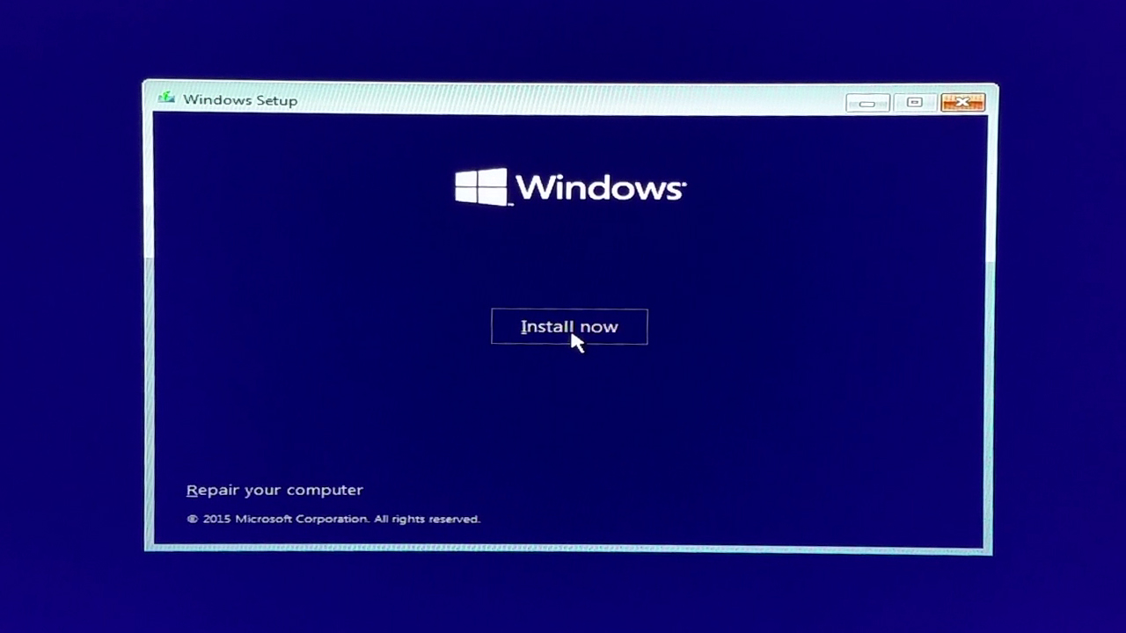

**Step-7:**   Wait for a few seconds for the setup to start.

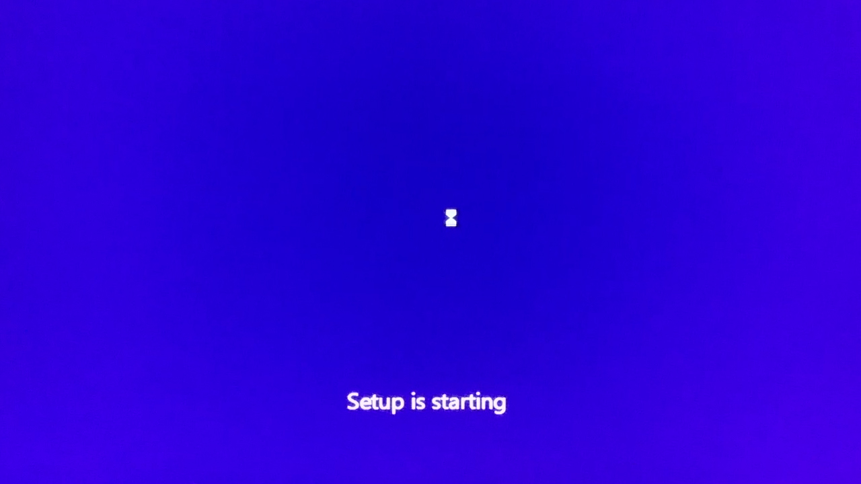

**Step-8:** If you have a product key, enter it, otherwise click on **Skip**.

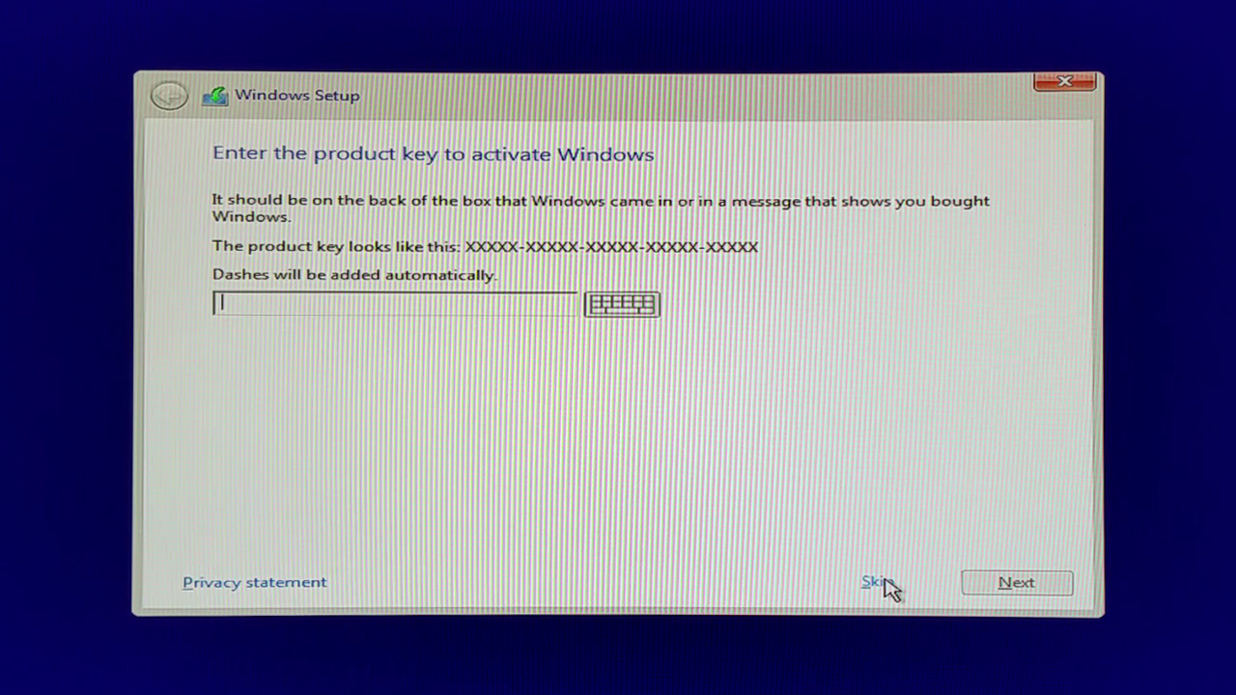

**Step-9:** Click the "Accept" box and click Next. This will indicate that you accept the terms of use.

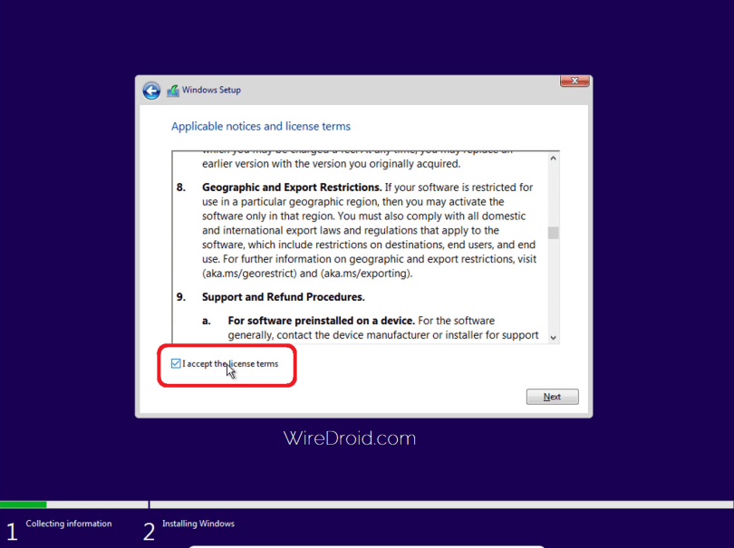

**Step-10:** “Which type of installation?” window will appear. Upgrade will be greyed out; the only option you should be able to choose is Custom (advanced).

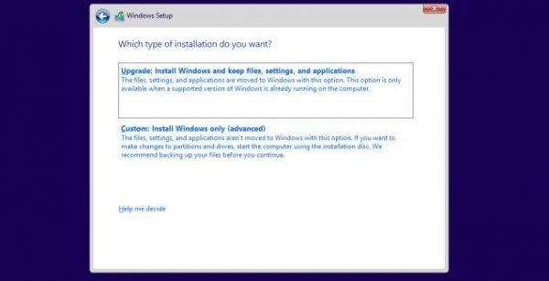

**Step-11:** You can choose to install your Windows 10 system file to a certain partition here.

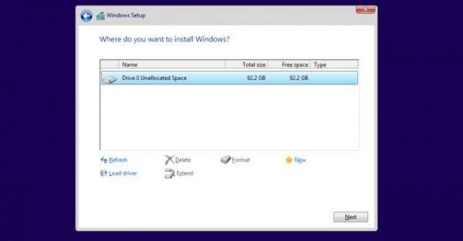

**Step-12:** Windows 10 is now installing.

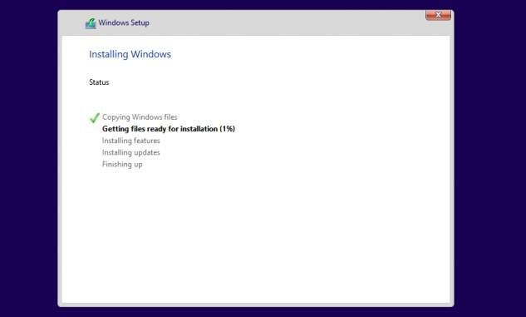

**Step-13:** Wait for a some more time.

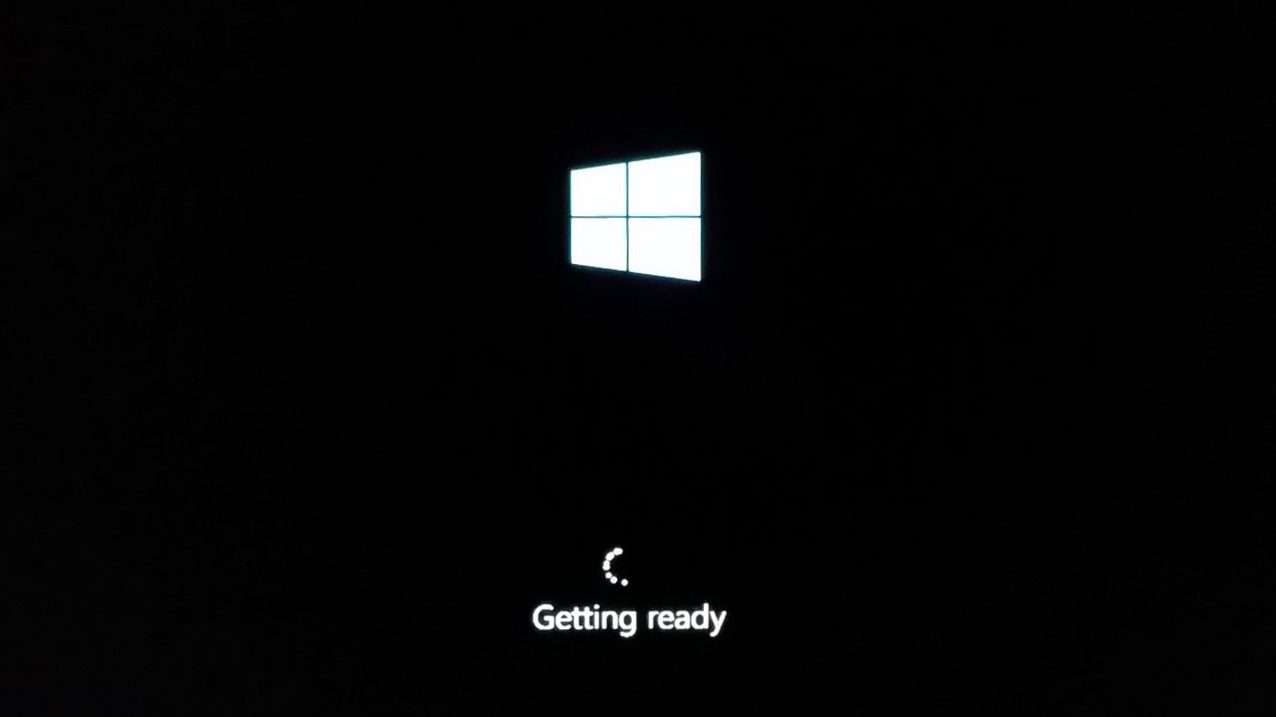

**Step-14:** Enter a serial key, otherwise click on **Do this later** to skip this option.

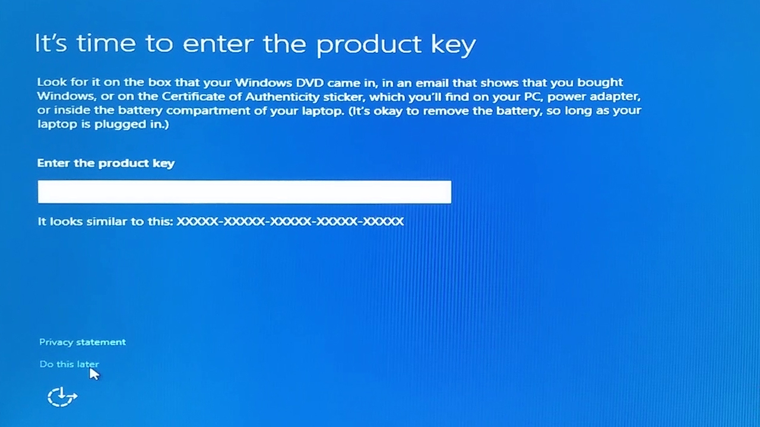

**Step-15:**  Click on **Use express settings** to use the recommended settings. Alternatively you can even click on **Customize settings** to customize the settings.

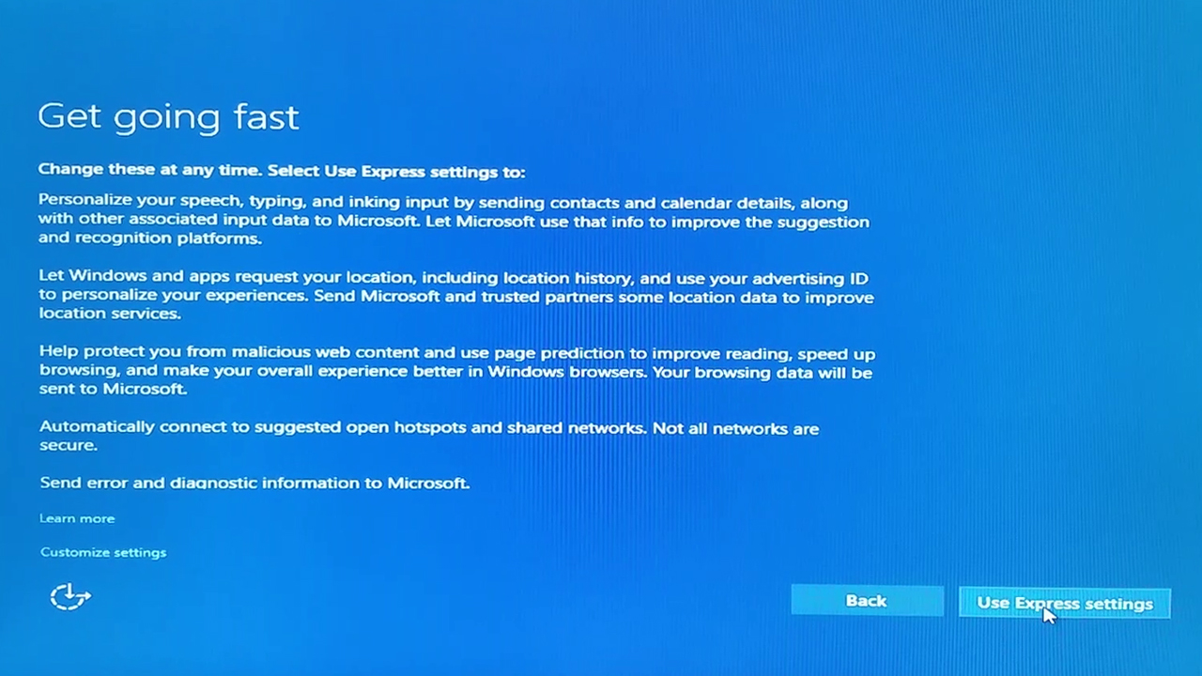

**Step-16:** Wait for a few seconds more.

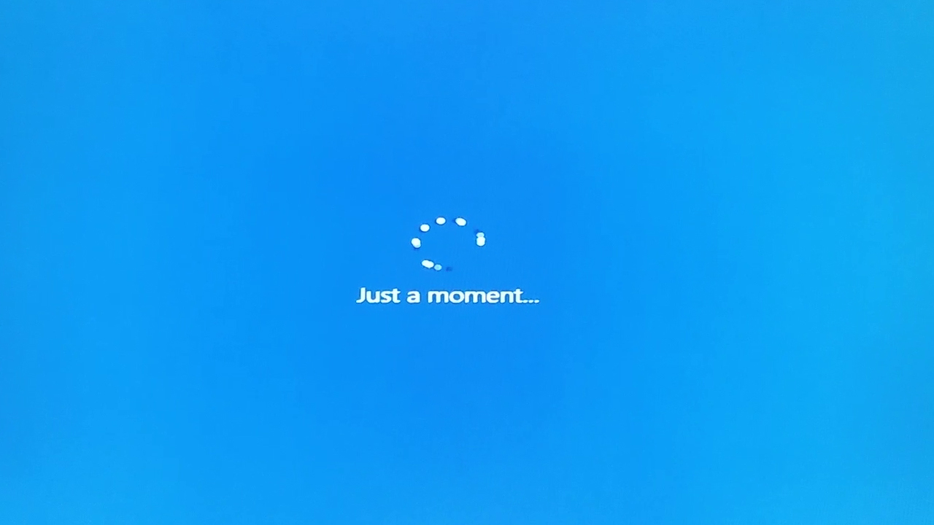

**Step-17:** Enter a name and password to create your account.

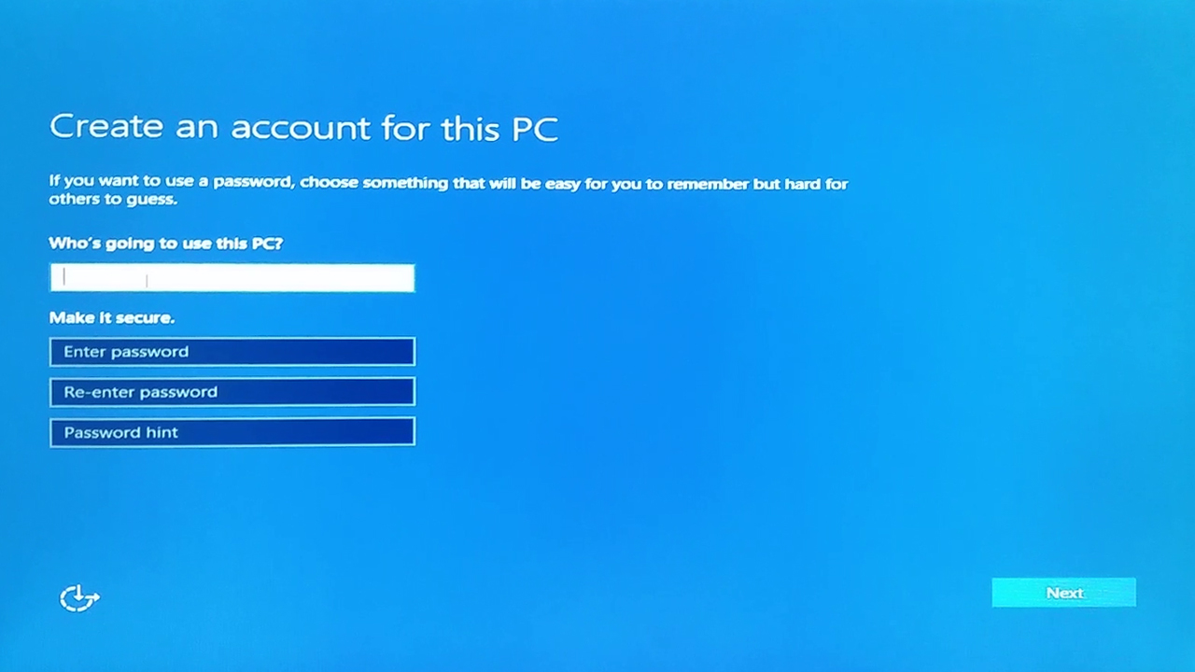

**Step-18:** Wait for a few seconds more.

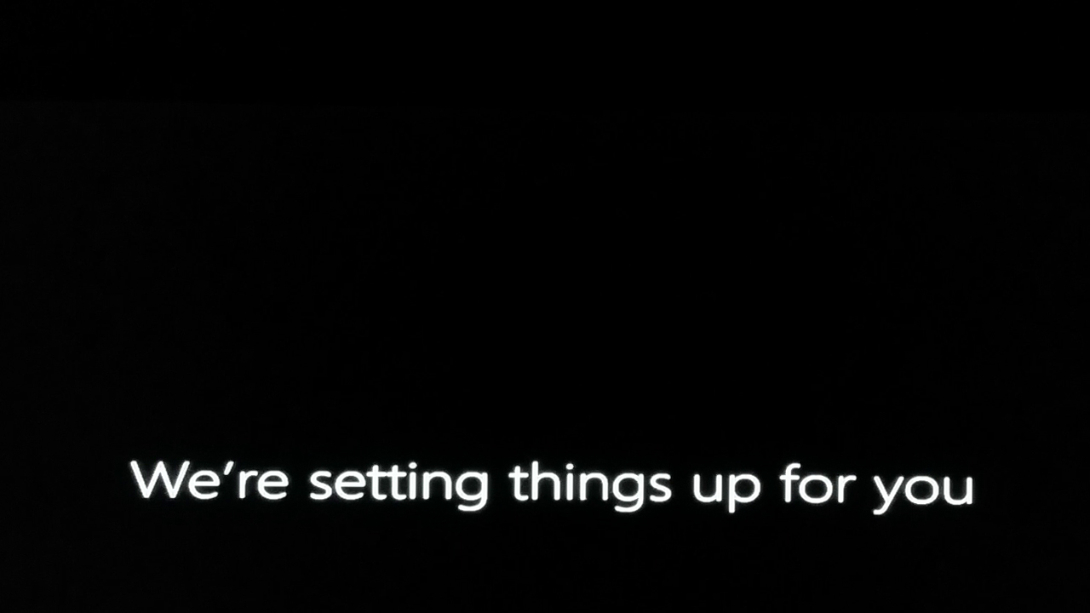

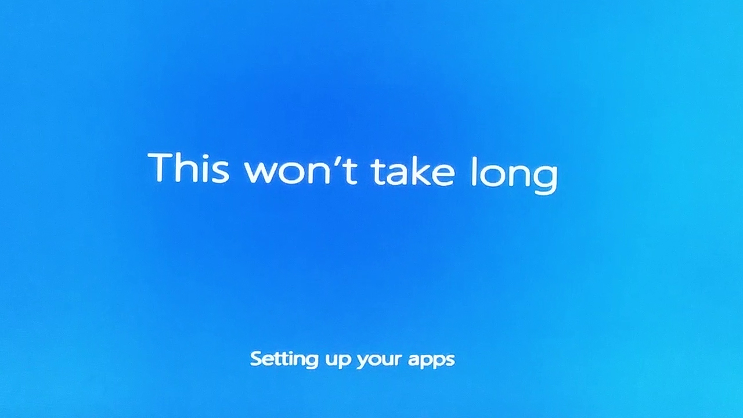

**Step-19:** here you go, you’re finally on Windows 10.

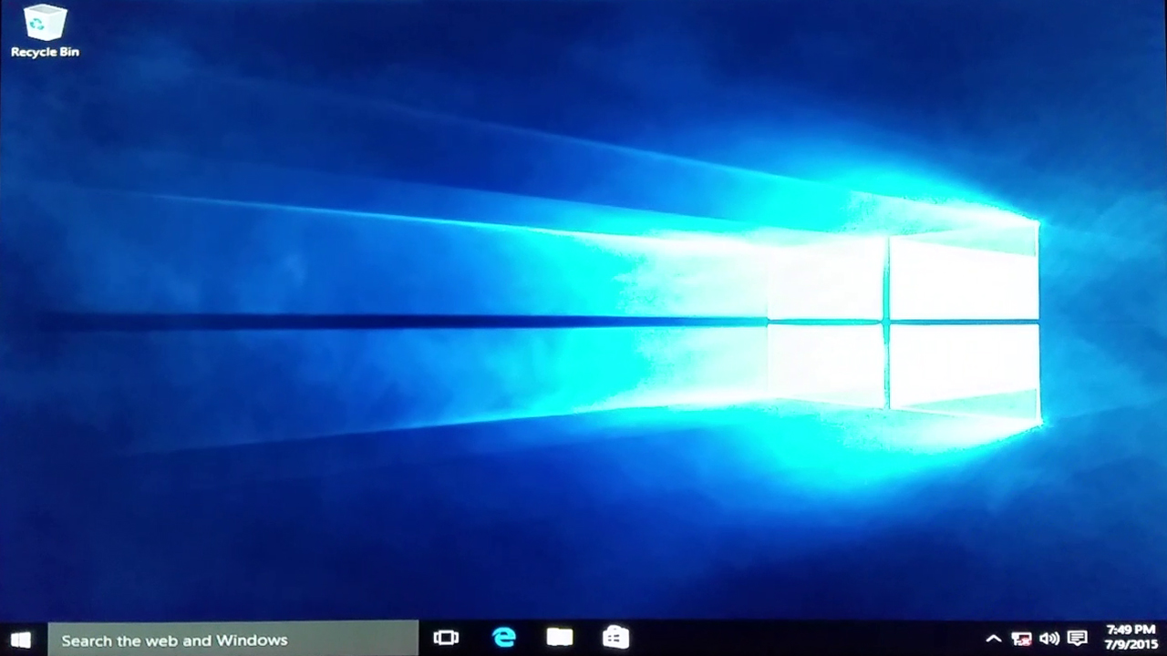

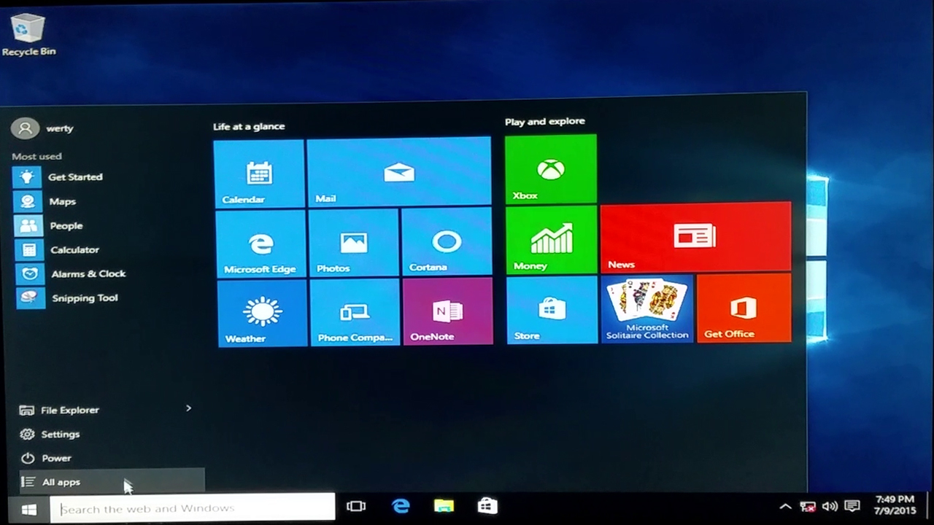

**TASK-4**

**Storage Devices**

**Interpreter**

An interpreter is a computer program that is used to directly execute program instructions written using one of the many high-level programming languages.The interpreter transforms the high-level program into an intermediate language that it then executes, or it could parse the high-level source code and then performs the commands directly, which is done line by line or statement by statement.

**Assembler**

An assembler translates assembly language programs into machine code.The output of an assembler is called an object file, which contains a combination of machine instructions as well as the data required to place these instructions in memory.

**Linker**

Linker is a computer program that links and merges various object files together in order to make an executable file. All these files might have been compiled by separate assemblers. The major task of a linker is to search and locate referenced module/routines in a program and to determine the memory location where these codes will be loaded, making the program instruction to have absolute references.

**Loader**

Loader is a part of operating system and is responsible for loading executable files into memory and execute them. It calculates the size of a program (instructions and data) and creates memory space for it. It initializes various registers to initiate execution.

**Cross-compiler**

A compiler that runs on platform (A) and is capable of generating executable code for platform (B) is called a cross-compiler.

**Source-to-source Compiler**

A compiler that takes the source code of one programming language and translates it into the source code of another programming language is called a source-to-source compiler.

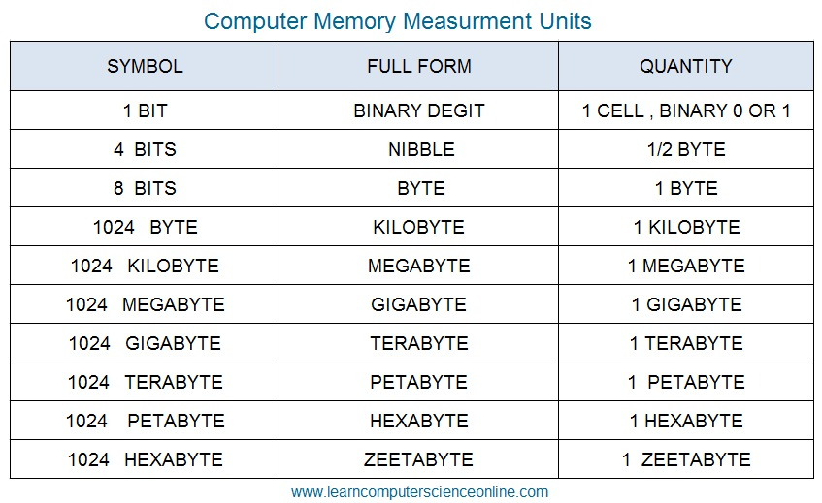

**TASK-5**

**Demonstration of Software and Hardware Troubleshooting**

**AIM:** Hardware troubleshooting

**Troubleshoot:-**

1. If you hit the power button & nothing happened.

* Check all power connections.
* Check for power on mother board.

1. If the system turns on but does not beep or begin to boot up.

* Remove all components except motherboard/ cpu / mother check by giving power to them

**Computer error beeps codes:**

* No beep: short, no power, bad CPU/ MD, loose peripherals.
* One beep: everything is normal & computer posted tax.
* Two beeps: post / CMOS error.
* One long beep One short beep: Motherboard problem.
* One long beep two short beep: video problem.
* One long beep 3 short beeps: video problem. 3 long beeps: keyboard error.
* Repeated long beep: memory error.

Continuous high- low beeps: CPU overheating Experiment no: 1

**AIM:** Software troubleshooting

**PROCEDURE:**

Error messages encountered during boot before Windows loads

Ensure that your computer BIOS settings are correctly configured to the hardware that is installed in your computer

Error messages while windows loading

* If you have recently installed or changed something that could have caused normal windows to stop loading, try loading the last known good configuration
* If you are unable to get into Normal windows and believe that removing or uninstalling a program or changing a setting may help enable you to get into windows, boot the computer into windows XP safe mode
* If your computer has worked fine in the past but recently has been experiencing the issue you are encountering run the system restore option to restore the computer to an earlier date Other error messages that occur while windows is loading or after windows is loaded

1. If error occur but windows still loads , verify no issues or conflict exits in device manager

2. Ensure that if programs are loading automatically that these errors are not associated with these programs

3. Make sure Windows XP is up to date by checking Microsoft windows update page

4. If your computer has virus protection installed make sure that it is up to date and that no virus are being detected

5. If your computer has worked fine in the past but recently has been experiencing the issue you are encountering run the system restore option to restore the computer to an earlier date.

The test consists of various systems with hardware/software troubleshooting related troubles, Formatted disks without operating systems

Take two motherboards, identify the components and explain the functionality of each component Given the various components of a computer identify and assemble them

Given a computer, disassemble it.

* Install any OS of choice
* Demonstrate basic Linux commands
* Install application software of choice
* Hardware troubleshooting
* Software troubleshooting

**TASK – 6**

**PURPOSE: To learn to surf the web**

**THEORY:**

* Web browser provides the means to the searching and also helps to download the web
* content.
* Web browsers support most of the famous Internet Protocols like HTTP,FTP.
* Common file formats a browser accepts are HTML
* Well known browsers natively support a variety of other formats in addition to HTML such as JPEG,PNG,GIF image formats

Different web browsers available in the market are:

* Netscape
* Mozilla
* Opera
* Safari
* Chrome

**Bookmark:**

Each web browser is built-in with the support of Internet Bookmarks which serve as a named

anchor – primarily to URLs. The primary purpose of this book mark is to easily catalog and access web pages that the web browser user has visited or plans to visit, without having to navigate the web to get there.

**Pop-up Blockers:**

Pop-ups are a form of online advertising on the WWW intended to attract the attention of the users. These pop ups are hosted on the web sites which are frequently visited by the netizens. These pop ups are activated when these web sites open a new web browser window and there by displaying the advertisements.

**Plug-ins:**

A plug-in is a software component program that interacts with a main application to provide a better integration of the media. The basic difference between application programs and plug-ins is that multimedia files are launched in a separate window where as in plug-ins multimedia play in the browser window.

**Few famous plug-ins are:**

* Apple Quick Time
* Macromedia flash
* Microsoft Media Player
* Adobe Shockwave
* Sun Micro systems Java Applet

**PROCEDURE:**

LAN Proxy Settings:

* select tools menu in Internet Explorer
* Select Internet Options
* Select Connections
* You end up in two options
  + Dial-up and virtual network settings
  + LAN setting
* The selection at this step is dependent on the kind of connection you are trying to configure. They are:
  + Dial-up modem connection
  + LAN connection
  + DSL or Cable modem

**PURPOSE:** To know what search engines are and how to use the search engines.

A search engine can be defined as a web site with tools which help you to find information on the internet Function of a search engine You can find anything from a schedule of White house tours to instructions for removing stains from clothes.

**Limitations:**

Search engines visit web sites only several weeks. Search engines cannot see information in other data bases later on.

On the internet a search engine is a coordinated set of programs that includes: A spider (crawler or bot) that goes to every page or representative pages on every web site that wants to be searchable and reads it , using hypertext links on each page to discover and read site’s other pages.

**Meta Search Engines:**

Meta search engines or “met crawlers” don’t crawl the web themselves. Instead they search the resources of multiple search engines by sending a search to several search engines at once aggregating the result.

**Pros:**

* You only need to use one search tool which is time- efficient
* You only need to learn how to use one search engine reducing learning curve
* You benefit from the difference among several search tools at once

**Cons:**

* Meta search services may not be able to leverage each individual search engines full range of query tools resulting in less refined searches
* You cannot personally select the search engines queried by meta search services.

**Viruses and/or worms.**

**PURPOSE:**

To learn various threats on the internet and configure the computer to be safe on the internet.

**THEORY**

Antivirus software is a program that either comes installed on your computer or that you purchase and install yourself. It protects your computer against most viruses, worms, Trojan horses and other unwanted invaders that can make your computer sick.

**Firewall:** A firewall is a special software or hardware designed to protect a private computer network from unauthorized access. A firewall is a set of related programs located at a network gateway server which protects the resources of the private network from users from other networks.

**PROCEDURE:**

Installing Symantec antivirus for Windows:

Insert Symantec antivirus CD into your CD drive

* Double click on the Symantec-setup.exe
* The installer will open
* Click next to proceed
* License agreement will open .Click I accept the terms of the license agreement and then click next.
* Follow the instruction on the screen to complete the installation.

Get Computer Updates:

* Click start> settings>control panel
* Click Automatic Updates icon to open Automatic Updates dialog box
* Check the box Keep my computer up to date
* Choose a setting
* Click OK

Block Pop ups:

* In the IE open tools>pop-up blocker
* Click on Turn on Pop- up blocker

Windows Firewall:

* Go to Start>control panel>Network and Internet Connections>windows firewall
* In the general tab check the On(recommended) box
* If you don’t want any exceptions check on Don’t allow exceptions box

A test which simulates all of the above tasks would be crafted and given to the students.

**TASK - 7**

**HTML**

**Introduction to HTML:**

HTML (**H**yper**t**ext **M**arkup **L**anguage) is the code that is used to structure a web page and its content. For example, content could be structured within a set of paragraphs, a list of bulleted points, or using images and data tables. As the title suggests, this article will give you a basic understanding of HTML and its functions.

**The main parts of our element are as follows:**

**The opening tag:** This consists of the name of the element (in this case, p), wrapped in opening and closing **angle brackets**. This states where the element begins or starts to take effect — in this case where the paragraph begins.

**The closing tag:** This is the same as the opening tag, except that it includes a *forward slash* before the element name. This states where the element ends — in this case where the paragraph ends. Failing to add a closing tag is one of the standard beginner errors and can lead to strange results.

**The content:** This is the content of the element, which in this case, is just text.

**The element:** The opening tag, the closing tag, and the content together comprise the element.

**Basic Tags**

HTML is a fairly straightforward programming language. Each tag starts with a < and ends with a >. For example the paragraph tag is <p>

There is a range of HTML tags, they help you to design your web page. There are four required tags in HTML. These are html, title, head and body. The table below shows you the opening and closing tag, a description and an example.

|  |  |
| --- | --- |
| **HTML Tag** | **Description** |
| <html> | These are the tags you put at the beginning and end of an HTML file. |
| <head> | This includes information including title, meta tags, content type, links to external pages like CSS and JavaScript. |
| <title> | This is the text that goes in the title bar or the browser window. |
| <body> | This contains the contents of the document |
| <h1> |  |

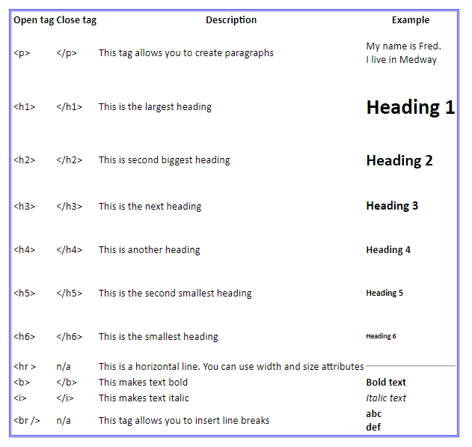

**HTML 5 Tags**

|  |  |
| --- | --- |
| **Tag** | **Description** |
| <article> | This element is used to define an independent piece of content in a document, that may be a blog, a magazine or a newspaper article. |
| <audio> | It is used to play audio file in HTML. |
| <canvas> | It is used to draw canvas. |
| <data> | It provides machine readable version of its data. |
| <details> | It specifies the additional information or controls required by user. |
| <dialog> | It defines a window or a dialog box. |
| <figcaption> | It is used to define a caption for a <figure> element. |
| <figure> | It defines a self-contained content like photos, diagrams etc. |
| <footer> | It defines a footer for a section. |
| <header> | It defines a header for a section. |
| <main> | It defines the main content of a document. |
| <mark> | It specifies the marked or highlighted content. |
| <nav> | It is used to define the navigation link in the document. |
| <progress> | It specifies the progress of the task. |
| <section> | It defines a section in the document. |
| <summary> | It specifies a visible heading for <detailed> element. |
| <time> | It is used to define a date/time. |
| <video> | It is used to play video file in HTML. |
| <wbr> | It defines a possible line break. |

**CSS Properties:**

Here are some basic CSS properties to work with.

1. [Text Properties](http://web.simmons.edu/~grabiner/comm244/weekthree/css-basic-properties.html#text)
2. [List Properties](http://web.simmons.edu/~grabiner/comm244/weekthree/css-basic-properties.html#list)
3. [Border Properties](http://web.simmons.edu/~grabiner/comm244/weekthree/css-basic-properties.html#border)
4. [Font Properties](http://web.simmons.edu/~grabiner/comm244/weekthree/css-basic-properties.html#font)

**Text Properties**

|  |  |  |
| --- | --- | --- |
| Property | Description | Values |
| color | Sets the color of a text | RGB, hex, keyword |
| line-height | Sets the distance between lines | normal, *number, length, %* |
| letter-spacing | Increase or decrease the space between characters | normal, *length* |
| text-align | Aligns the text in an element | left, right, center, justify |
| text-decoration | Adds decoration to text | none, underline, overline, line-through |
| text-indent | Indents the first line of text in an element | *length, %* |
| text-transform | Controls the letters in an element | none, capitalize, uppercase, lowercase |

**List Properties**

|  |  |  |
| --- | --- | --- |
| **Property** | **Description** | **Values** |
| list-style | Sets all the properties for a list in one declaration | *list-style-type, list-style-position, list-style-image,*inherit |
| list-style-image | Specifies an image as the list-item marker | URL, none, inherit |
| list-style-position | Specifies where to place the list-item marker | inside, outside, inherit |
| list-style-type | Specifies the type of list-item marker | none, disc, circle, square, decimal, decimal-leading-zero, armenian, georgian, lower-alpha, upper-alpha, lower-greek, lower-latin, upper-latin, lower-roman, upper-roman, inherit |

**Font Properties**

|  |  |  |
| --- | --- | --- |
| Property | Description | Values |
| font | Sets all the font properties in one declaration | font-style, font-variant, font-weight, font-size/line-height, font-family, caption, icon, menu, message-box, small-caption, status-bar, inherit |
| font-family | Specifies the font family for text | *family-name, generic-family,*inherit |
| font-size | Specifies the font size of text | xx-small, x-small, small, medium, large, x-large, xx-large, smaller, larger*, length, %,*inherit |
| font-style | Specifies the font style for text | normal, italic, oblique, inherit |
| font-variant | Specifies whether or not a text should be displayed in a small-caps font | normal, small-caps, inherit |
| font-weight | Specifies the weight of a font | normal, bold, bolder, lighter, 100, 200, 300, 400, 500, 600, 700, 800, 900, inherit **Careful, many of these are not supported!** |

**Border Properties**

|  |  |  |
| --- | --- | --- |
| Property | Description | Values |
| border | Sets all the border properties in one declaration | border-width, border-style, border-color |
| border-bottom | Sets all the bottom border properties in one declaration | border-bottom-width, border-bottom-style, border-bottom-color |
| border-bottom-color | Sets the color of the bottom border | border-color |
| border-bottom-style | Sets the style of the bottom border | border-style |
| border-bottom-width | Sets the width of the bottom border | border-width |
| border-color | Sets the color of the four borders | color_name, hex_number, rgb_number, transparent, inherit |

**Develop your home page using HTML Consisting of your photo, name, address and education details as a table and your skill set as a list**

**Aim:-** To create a your web page using HTML

**Software Requirement:** Notepad, Any web browser

**Hardware Requirement:** Personal computer

**CODE:**

<html>

<head>

<title> details</title>

</head>

<body>

<img src="photo.jpg" height=100 width=100>

<h1> NAME : Radha</h1>

<h1><pre> Address: H.NO.1-241/29, Kukatpally, Hyderabad-500062 </pre></h1> <h1> Educational Details</h1>

<table border=1>

<tr>

<th>Course </th>

<th>Name of the Institutation</th>

<th>Year of Pass</th>

<th>Percentage</th>

</tr>

<tr>

<td>M.Tech(CSE)</td><td>SVEC</td> <td>2011</td> <td>81%</td> </tr> <tr> <td>B.TEch(CSE) </td> <td>CVR Engineering College</td> <td>2009</td> <td>75%</td> </tr> <<tr> <<td>Intermediate </td> <td>Sri Chaitanya</td> <td>2005</td> <td>89%</td> </tr> <td>SSC</td> <td>Little Buds High School</td> <td>2003</td> <td>85%</td> </tr> </table>

<h1>Technical Skills:</h1>

<ul type=disc>

<li>Programming Languages : C, JAVA</li>

<li>OperatingSystems : Windows </li>

<li>DatabaseSystems : Oracle</li>

<li>Web Technologies </ul>

</body>

</html>

**Output**

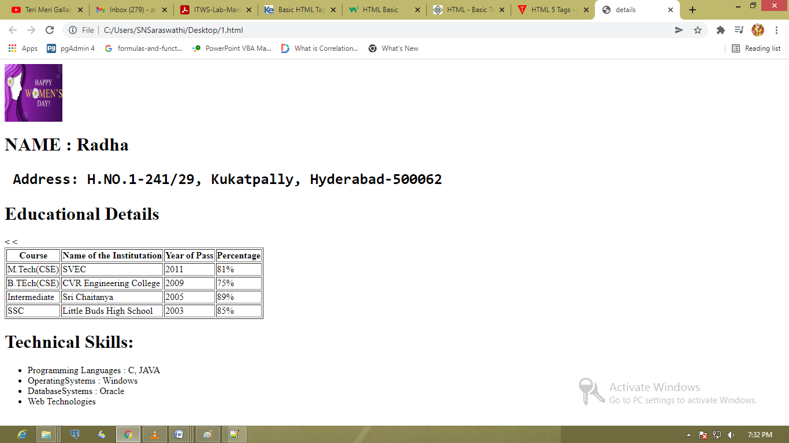

**TASK - 8**

**Demonstration and Practice of various features Microsoft Word**

**Important Features of Ms-Word**

Ms-Word not only supports word processing features but also DTP features. Some of the important features of Ms-Word are listed below:

1. Using word you can create the document and edit them later, as and when required, by adding more text, modifying the existing text, deleting/moving some part of it.
2. Changing the size of the margins can reformat complete document or part of text.
3. Font size and type of fonts can also be changed. Page numbers and Header and Footer can be included.
4. Spelling can be checked and correction can be made automatically in the entire document. Word count and other statistics can be generated.
5. Text can be formatted in columnar style as we see in the newspaper. Text boxes can be made.
6. Tables can be made and included in the text.
7. Word also allows the user to mix the graphical pictures with the text. Graphical pictures can either be created in word itself or can be imported from outside like from Clip Art Gallery.
8. Word also has the facility of macros. Macros can be either attached to some function/special keys or to a tool bar or to a menu.
9. It also provides online help of any option.

**The Microsoft Office Button:**

The Microsoft Office button performs many of the functions that were located in the File menu of older versions of Word. This button allows you to create a new document, open an existing document, save or save as, print, send (through email or fax), publish or close.

**The Ribbon:**

The Ribbon is the panel at the top portion of the document. It has seven tabs:

1. Home
2. Insert
3. Page Layout
4. References
5. Mailings
6. Review
7. View

Each tab is divided into groups. The groups are logical collections of features designed to perform functions that you will utilize in developing or editing your Word document. Commonly used features are displayed on the Ribbon, to view additional features within each group, click on the arrow at the bottom right of each group.

Each of the tabs contains the following tools:

**Home:** Clipboard, Fonts, Paragraph, Styles, and Editing.

**Insert:** Pages, Tables, Illustrations, Links, Header & Footer, Text, and Symbols

**Page Layout:** Themes, Page Setup, Page Background, Paragraph, Arrange

**References:** Table of Contents, Footnote, Citation & Bibliography, Captions, Index, and Table of Authorities

**Mailings:** Create, Start Mail Merge, Write & Insert Fields, Preview Results, Finish

**Review:** Proofing, Comments, Tracking, Changes, Compare, Protect

**View:** Document Views, Show/Hide, Zoom, Window, Macros

**Quick Access Toolbar:**

The quick access toolbar is a customizable toolbar that contains commands that you may want to use. You can place the quick access toolbar above or below the ribbon. To change the location of the quick access toolbar, click on the arrow at the end of the toolbar and click on Show below the Ribbon.

**Create a New Document**

* Click the **Microsoft Office Button** and Click **New**
* New Document dialog will be displayed
* Select Blank Document and click on Create Butto

**Opening an Existing Document:**

* Click the **Microsoft Office Button** and Click **Open,** or
* Press CTRL+O (Depress the CTRL key while pressing the ―O‖) on the keyboard, or
* If you have recently used the document you can click the **Microsoft Office Button** and click the name of the document in the **Recent Documents** section of the window Insert picture of recent docs

**Saving a Document:**

* Click the **Microsoft Office Button** and Click **Save** or **Save As** (remember, if you‘re sending the document to someone who does not have Office 2007, you will need to click the **Office Button**, click **Save As**, and Click **Word 97-2003 Documen**t), or
* Press CTRL+S (Depress the CTRL key while pressing the ―S‖) on the keyboard, or
* Click the **File** icon on the Quick Access Toolbar

**Rename:**

To rename a Word document while using the program:

* Click the **Office Button** and find the file you want to rename.
* Right-click the document name with the mouse and select **Rename** from the shortcut menu.
* Type the new name for the file and press the **ENTER** key.

**Close:**

To close a document:

* Click the **Office Button**
* Click **Close**

**Formatting fonts:**

Font formatting allows you to Change font style, size, color and a large number of other features. You can also change the spacing between letters here.

**Cell Alignment:**

Aligns contents written in a table in the top left corner or top right corner or in the center etc...

**Symbols:**

You may not be able to enter certain symbols into your word document, as there is a limitation on the keys on the key board. Creating these new symbols especially when working with mathematical terms it becomes very difficult.

**Drop Caps*:***

Drop caps are those giant letters that begin the first paragraph of a chapter or document. They get your readers attention by standing out and demanding focus.

**Aim:** *C*reate a project certificate.

**Step-1:** Launch Ms-Word -> Click on New button

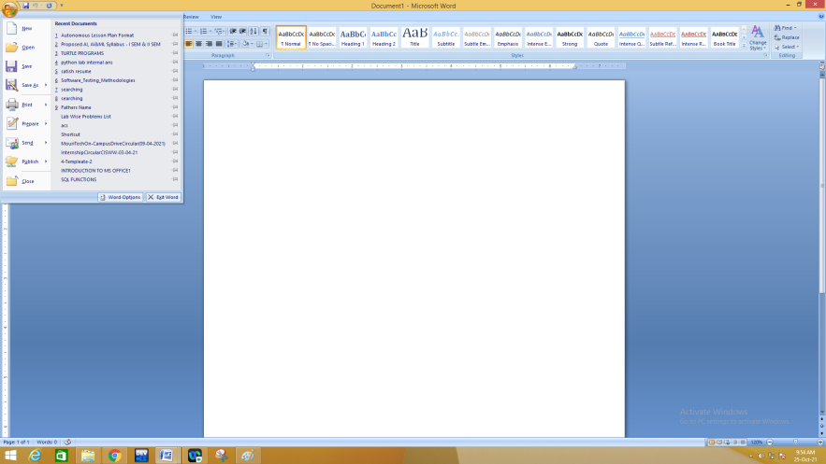

**Step-2:** Navigate to Paragraph Ribbon. Click in Bottom boarder  button.

Click on Boarders & Shading Button

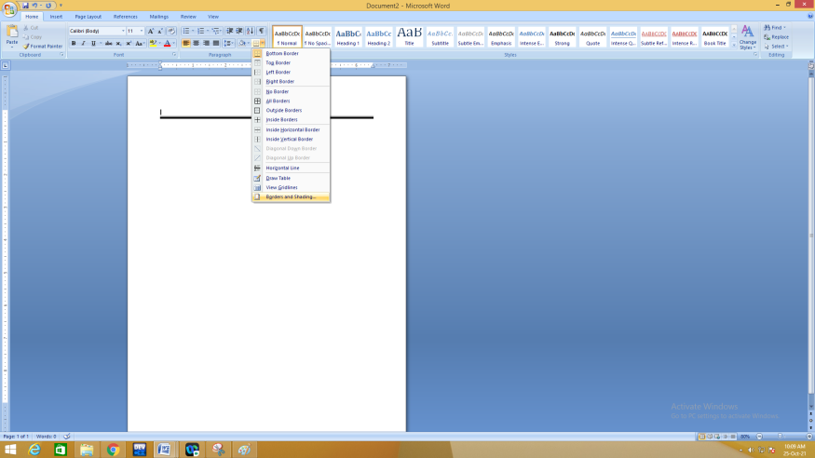

**Step-3:**Click on Page Border & Select Box shape ,Choose appropriate style ,Click on OK button

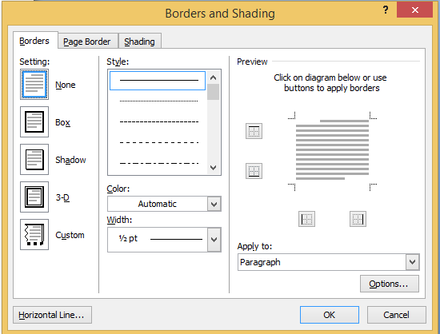

**Step-4:** Enter the details of certificate , insert image & align center

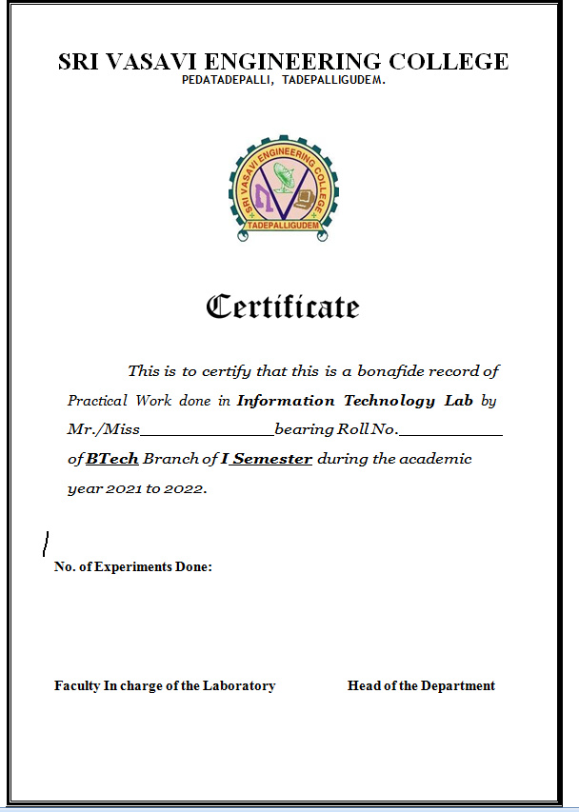

**2. Creating Newsletters in Microsoft Word**

This document provides instructions for creating newsletters in Microsoft Word.

**Opening Comments**

There are several software applications that can be used for creating newsletters, including applications dedicated to publications, like Microsoft Publisher. However, simple newsletters can be created in Word, using tools you are already familiar with (or can quickly become familiar with).

**Creating Columns**

Newsletters are often formatted into multiple columns.

1. To create columns in Word, on the **Page Layout** tab, choose **Columns**. Select the appropriate number of columns or click **More Columns** for additional settings, including the width of each column and whether you want a line between the columns.

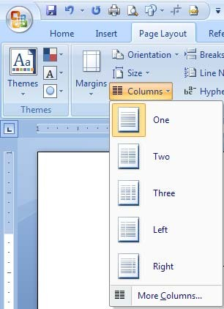

1. 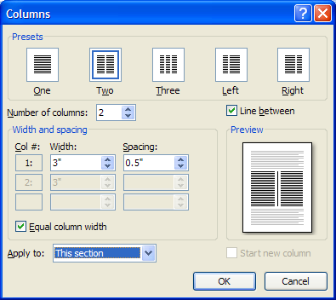Select the appropriate number of columns or click **More Columns** for additional settings, including the width of each column and whether you want a line between the columns.
2. Your document is then divided into columns, including any text you had already entered. Note the column space in the ruler.

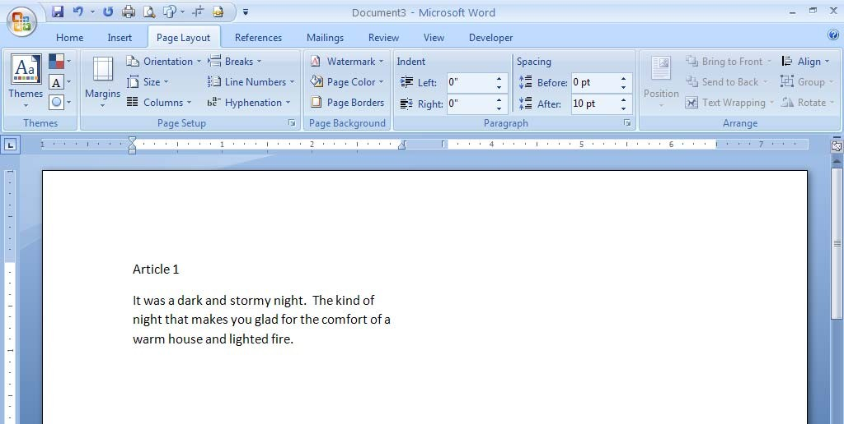

**Column Breaks**

As you fill the first column with text, the text will automatically wrap around and into the next column. However, there may be times when you want to begin entering text into a column before the previous column is full. In these situations, you can use column breaks (similar to entering manual page breaks).

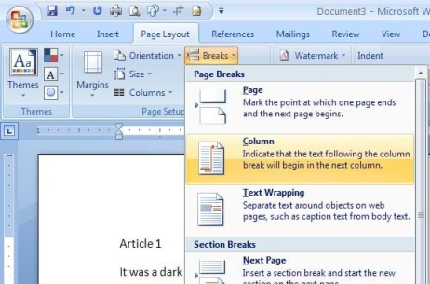Place your cursor where you would like to begin the next column.

On the **Page Layout** tab, click **Breaks**. Then select **Column**.

You can now begin entering text into the next column.

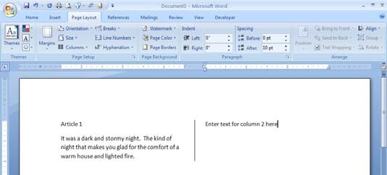

**Section Breaks**

There may be times when you want only certain parts of the newsletter to be formatted in columns. For example, your newsletter may have a heading that you would like to center across the entire page. We divide documents into sections in these situations. Each section can have different formatting characteristics.

To divide a document into multiple sections, place your cursor where you would like the next section to begin.

On the **Page Layout** tab, select **Continuous** in the **Section Breaks** area. (Notice that

there are also options for creating a section break that starts on a new page. This is helpful for when you want to change the page orientation or headers/footers on different pages.)

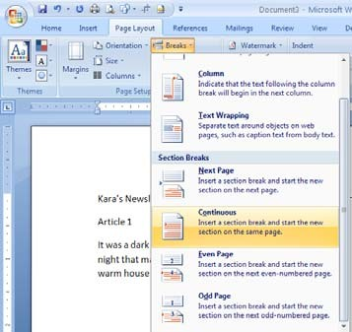

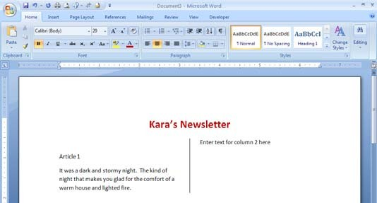You can now format one section without altering the format of the next section.

Also, note the status bar will indicate in which section you are working. If the status bar does not display the sections, you can **right-click the status bar** and choose **Section**.

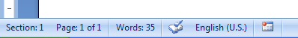

**TASK - 9**

**Demonstration and Practice of various features Microsoft Excel**

**Aim**: -

Develop a spread sheet to maintain the student marks list using MS Excel. The Features to be covered are Gridlines, Format cells, manual summation, auto summation, auto fill, Formatting Text.

**Introduction to MS-Excel**

Excel is a computerized spreadsheet, which is an important business tool that helps you report and analyze information. Excel stores spreadsheets in documents called workbooks. Each workbook is made up of individual worksheets, or sheets. Because all sorts of calculations can be made in the Excel spreadsheet, it is much more flexible than a paper spreadsheet. The Excel window has some basic components, such as an Active cell, Column headings, a Formula bar, a Name box, the mouse pointer, Row headings, Sheet tabs, a Task Pane, Tab scrolling buttons and Toolbars.

Sample Worksheet

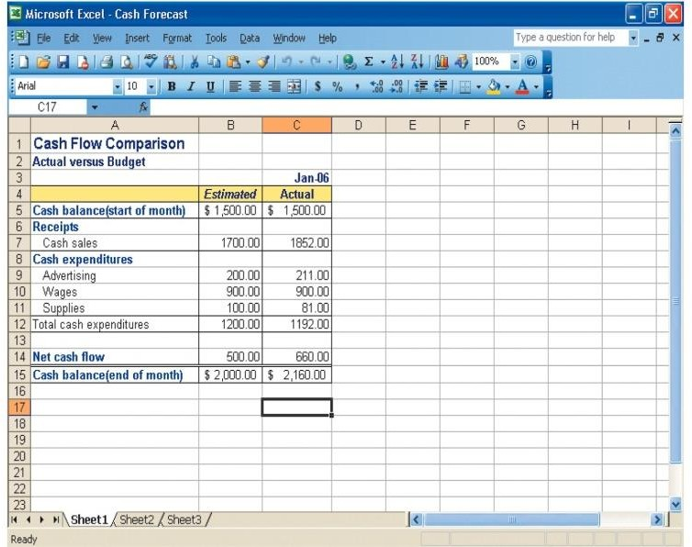

**Excel worksheet and workbooks**

When you set up calculations in a worksheet, if an entry is changed in a cell, the spreadsheet will automatically update any calculated values that were based on that entry. When you open Excel, by default it will open a blank workbook with three blank worksheets. When you save a workbook, you have a Save As option that can save the spreadsheet to earlier versions of Excel or to Quattro Pro, Lotus 123 formats, dBase formats, and even to a comma or tab-delimited textfile.

**Identify Excel components**

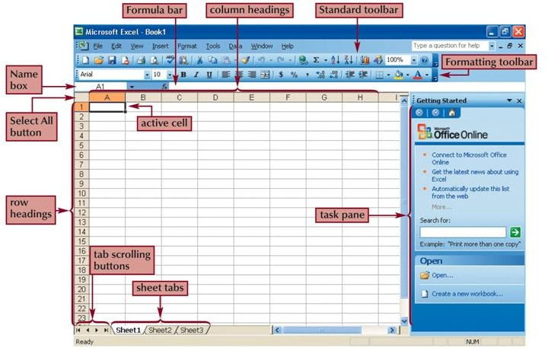

**Navigate within worksheet**

To navigate within a workbook, you use the arrow keys, Page Up, Page Down, or the Ctrl key in combination with the arrow keys to make large rmovements.The most direct means of navigation is with your mouse.

Scroll bars are provided and work as they do in all Windows applications.To move to other Worksheets, you can:

* Click their tab with the mouse
* Use the Ctrl key with the Page Up and Page Down keys to move sequentially up or down through the worksheets.

If you are familiar with Microsoft Access, you will find the tab scrolling buttons for moving between worksheets to be similar to record browsing on an Access form or datasheet.

**Entering data into a worksheet**

To enter data, first make the cell in which you want to enter the data active by clicking it. Enter the data (text, formulas, dates, etc.) into the active cell.

Use the Alt+Enter key combination to enter text on multiple lines within the same cell. Use TAB key, arrow keys, or ENTER key to navigate among the cells.

**Entering Formulas**

A formula is a mathematical expression that calculates a value. In Excel, formulas always begin with an equal sign (=).A formula can consist of one or more arithmetic operators. The order of precedence is a set of predefined rules that Excel follows to calculate a formula.

**Resize worksheet rows and columns**

There are a number of methods for altering row height and column width using the mouse or menus:

Click the dividing line on the column or row, and drag the dividing line to change the width of the column or Height of the row Double-click the border of a column heading, and the column will increase in width to match the length of the longest entry in the column Widths are expressed either in terms of the number of characters or the number of screen pixels.

**Identify cell ranges**

A group of worksheet cells is known as a cell range, or range.

* Working with ranges in a worksheet makes working with the data easier.
* Ranges can be adjacent or nonadjacent.
* An adjacent range is a single, rectangular block of cells
* Select an adjacent range by clicking on a cell and dragging to an opposite corner of a rectangle of cells
* A nonadjacent range is comprised of two or more adjacent ranges that are not contiguous to each other.
* To select a nonadjacent range, begin by selecting an adjacent range, then press and hold down the Ctrl key as you select other adjacent ranges

**Select and move worksheet cells**

To select a large area of cells, select the first cell in the range, press and hold the Shift key, and then click the last cell in the range.

Once you have selected a range of cells, you may move the cells within the worksheet by clicking and dragging the selection from its current location to its new one.

By pressing and holding the Ctrl key as you drag, Excel will leave the original selection in its place and paste a copy of the selection in the new location. To move between workbooks, use the Alt key while dragging the selection.

**Insert worksheet rows and columns**

You can insert one or many additional rows or columns within a worksheet with just a few steps using the mouse or menu options. You can insert individual cells within a row or column and then choose how to displace the existing cells. You can click the Insert menu and then select row or column, or right click on a row or column heading or a selection of cells and then choose Insert from the shortcut menu.

**Delete worksheet rows and columns**

To delete and clear cells, rows, or columns, you can use the Edit menu, or right click on a heading or a selection of cells and choose Delete from the shortcut menu. Clearing, as opposed to deleting, does not alter the structure of the worksheet or shift unclear data cells. What can be confusing about this process is that you can use the Delete key to clear cells, but it does not remove them from the worksheet as you might expect.

**Use undo and redo features**

Editing is an intrinsic task in any document, and especially useful are the Undo and Redo actions. The Undo feature allows you to sequentially back up to a certain action, such as a delete, a move, an entry, etc. And allows you to reverse those actions.

Redo allows you to reapply actions one step at a time that you have previously undone.

Print as workbook

To print a worksheet, you can use:

A menu

The Print button on the standard toolbar

The Ctrl-P keystroke to initiate a printout of the worksheet

**1. Creating A Scheduler**

1. Start Excel and open a new, blank workbook.

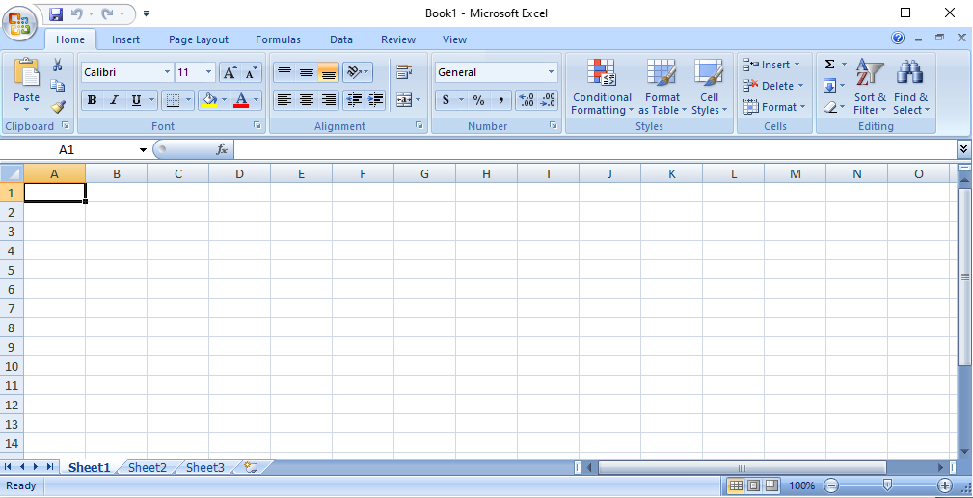

1. Select the [cell range](https://www.lifewire.com/description-of-range-3123975) **A1:E2**, then select **Merge & Center**in the Alignment group of the Home tab.

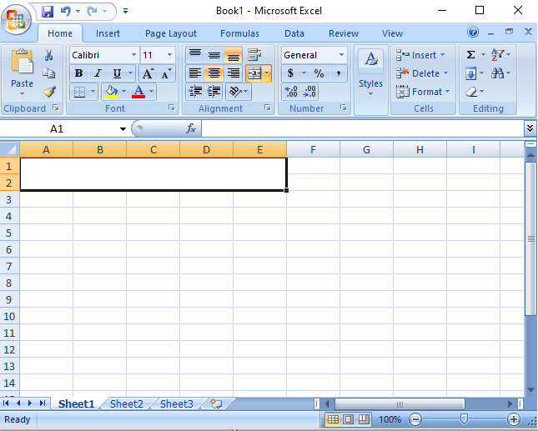

1. Type "**WEEKLY SCHEDULE**"into A1:E2, change the font size to 18,and select **Middle Align**in the Alignment group.

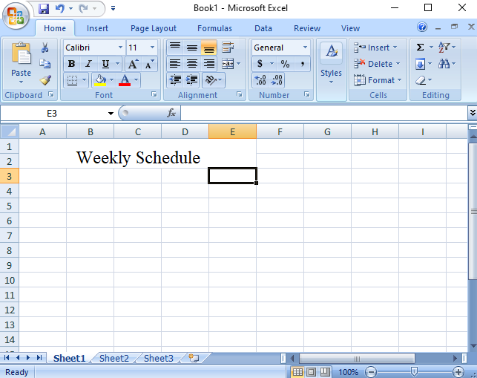

1. Select cells **F1:H2**, select the **Borders**drop-down in the Font group of the Home tab, then select **All Borders**.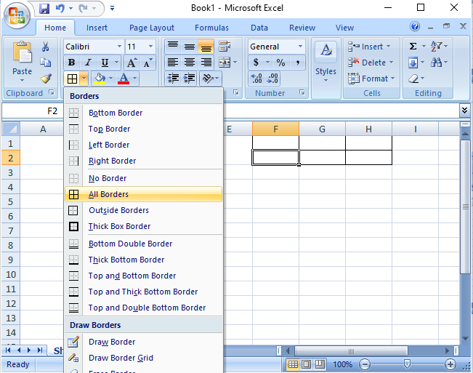
2. Enter "**Daily Start Time**"into F1; "**Time Interval**" into G1; and "**Starting Date**" into H1. Choose the **Select All**icon (between 1 and A on the worksheet), then double-click the line separating any two columns to resize all cells to fit the contents.

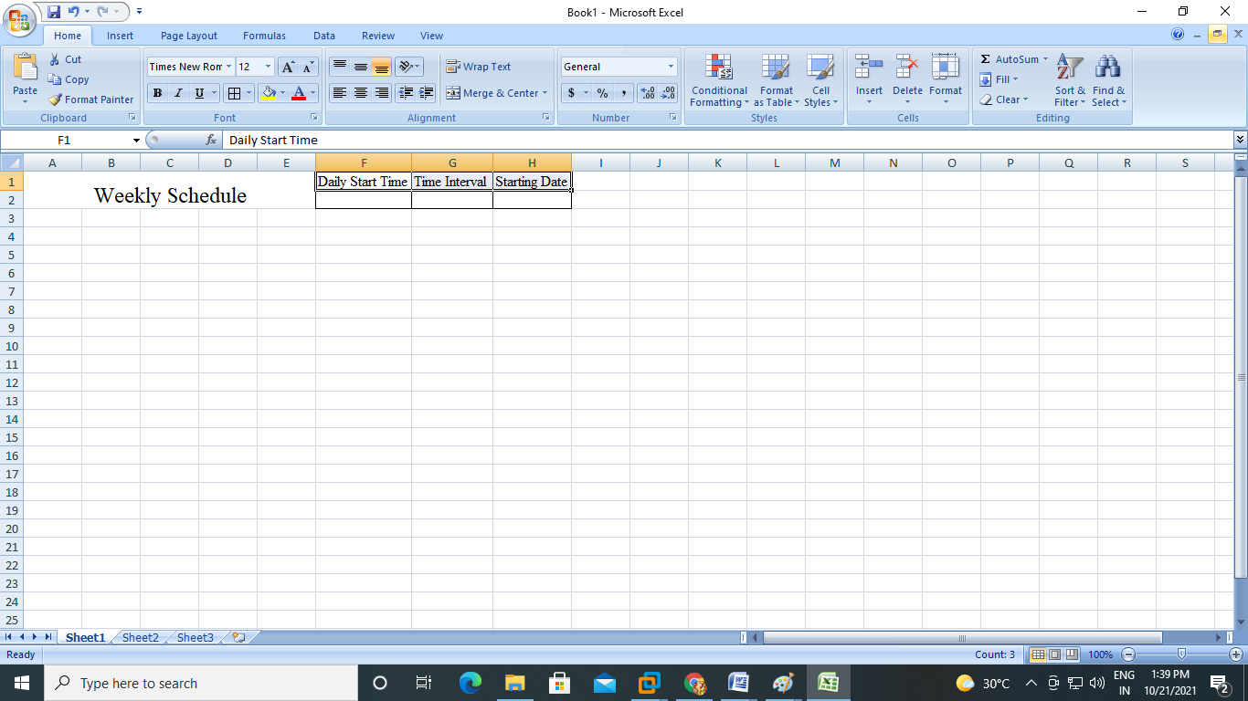

1. Select cell **A3**and enter "**TIME**."

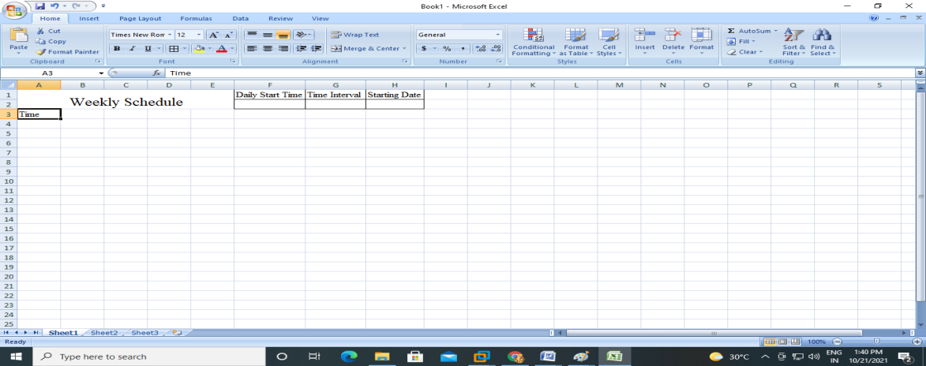

1. Select cell **A4**and enter the time you want your schedule to begin. To follow this example, enter "**7:00**."

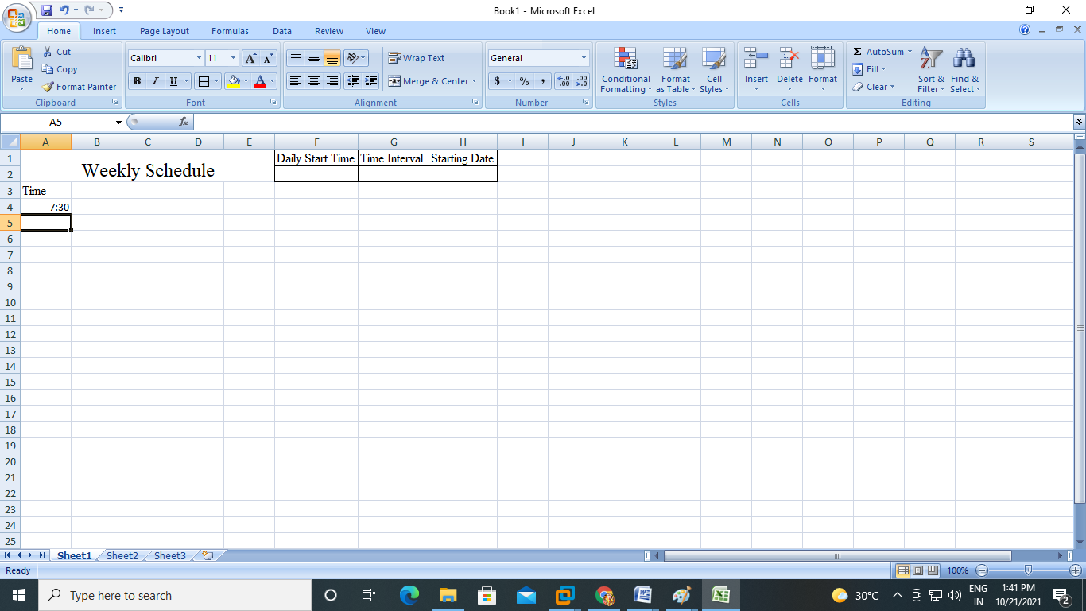

1. In cell A5, enter the next interval you want to list in the schedule. To follow this example, enter "**7:30**." Select **A4:A5** and drag the [fill handle](https://www.lifewire.com/excel-fill-handle-3123804) down to fill the time increments for the rest of the day.

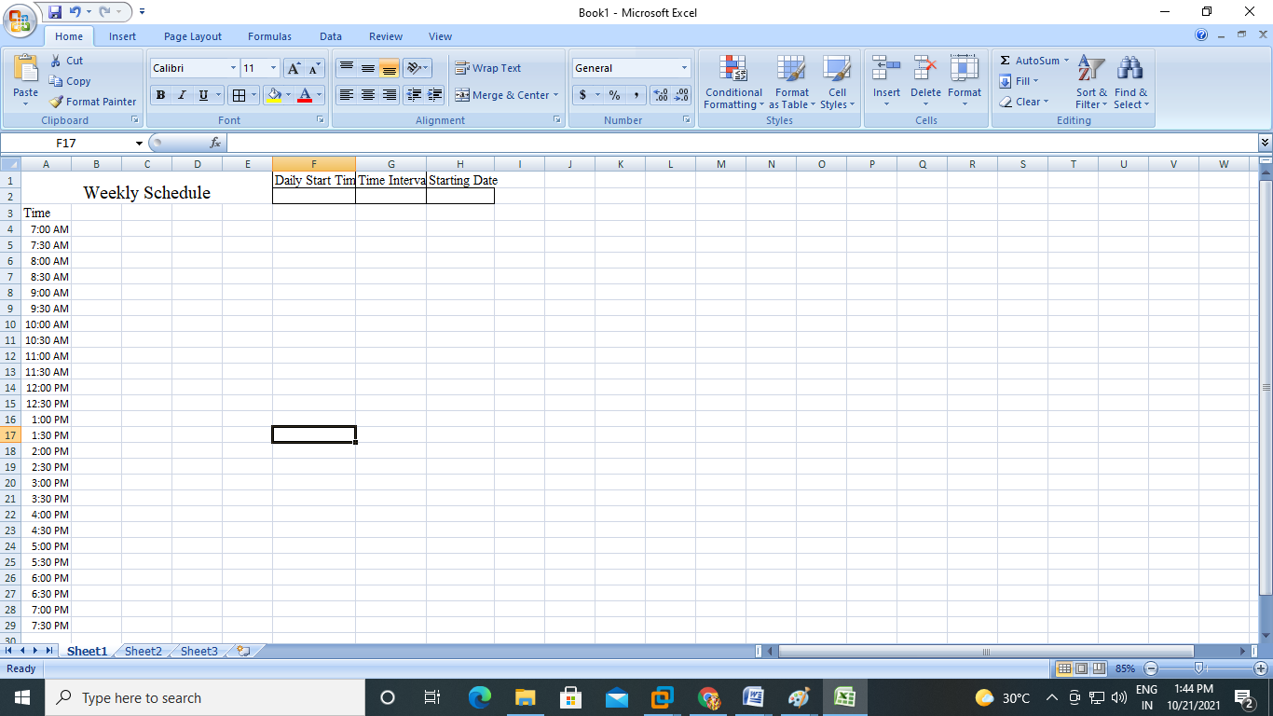

1. In cell B3, enter the day of the week with which you want your schedule to begin. To follow this example, enter "**SUNDAY**."

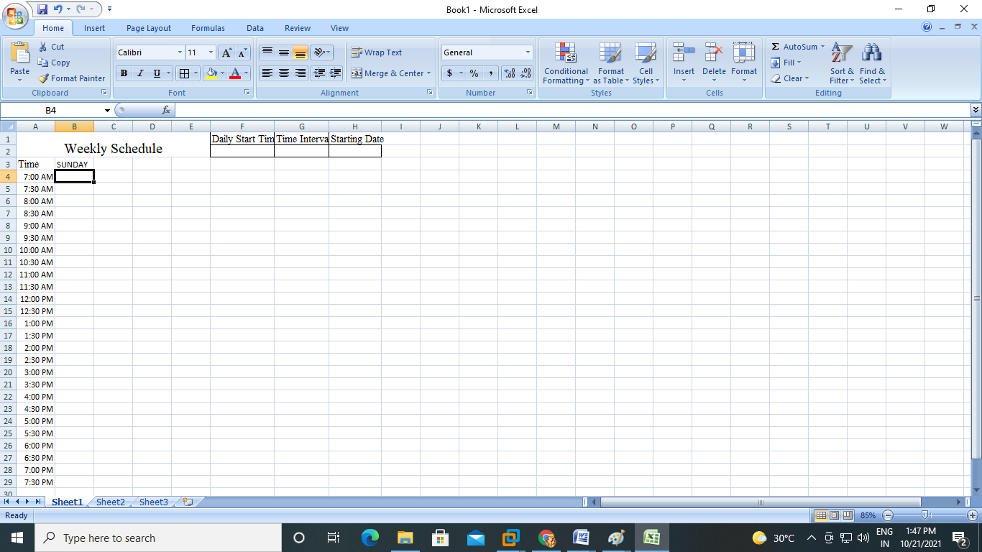

1. Drag the **fill handle** to the right to automatically fill the remaining days of the week on the schedule.

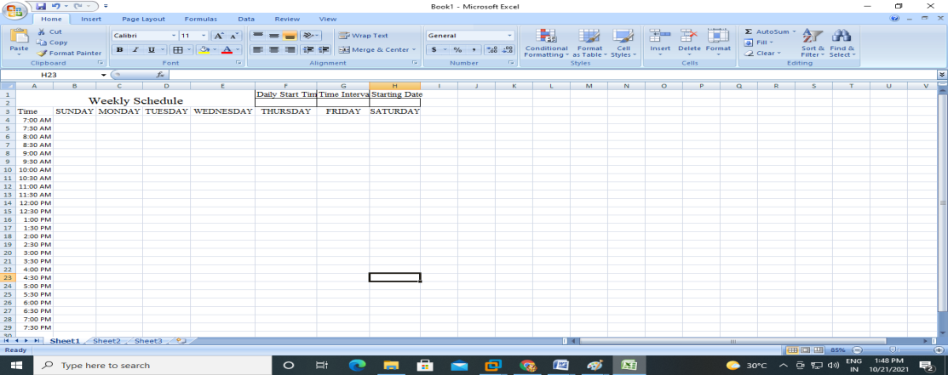

1. Select the **Select All** icon or press **Ctrl+A**and select **Center**in the Alignment group of the Home tab.

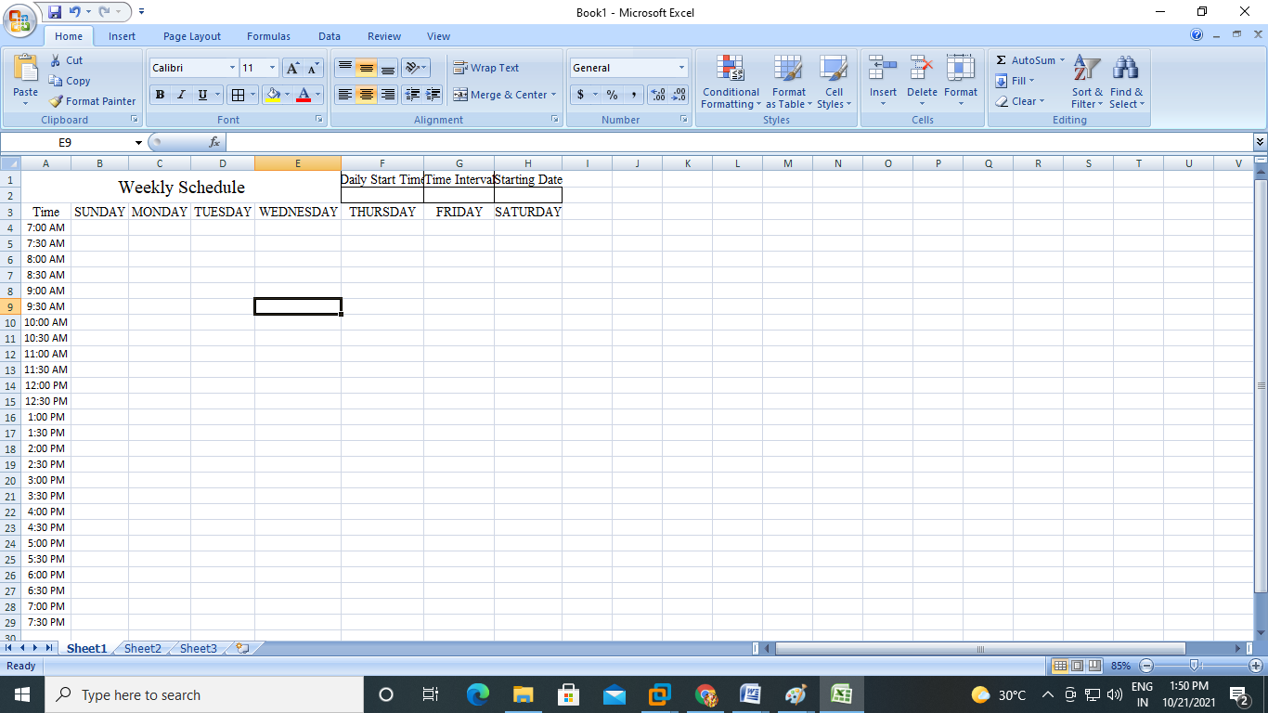

1. Select cells **A1:H2**.Select the **Fill Color**drop-down from the Font group of the Home tab and choose a fill color for the selected cells.

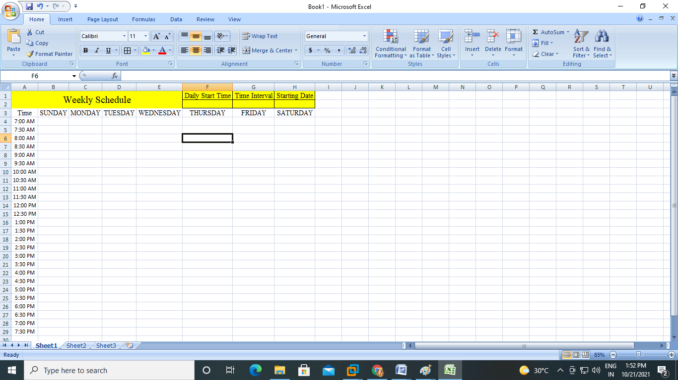

1. Choose a unique fill color for each of the following cells or ranges:

A3, B3:H3, A4:A28 (or the range of cells containing times on your worksheet)

B4:H28(or the range of cells making up the remainder of your schedule)

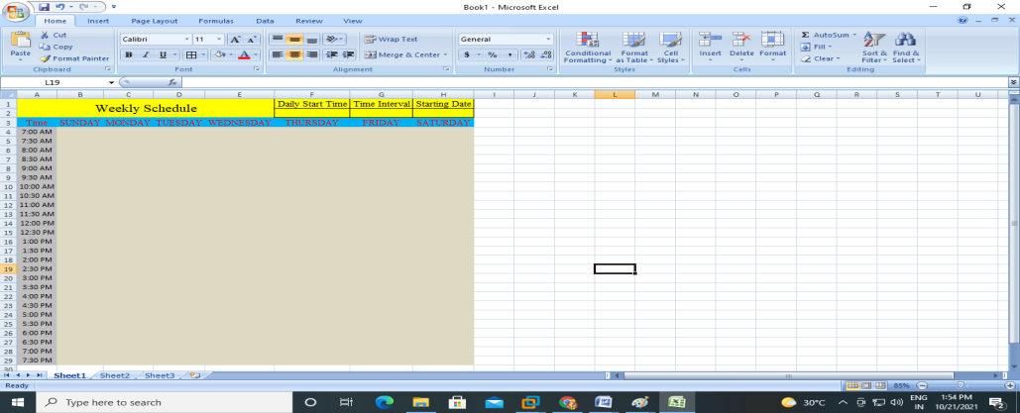

1. Select the body of the schedule. Select the **Borders**drop-down in the Font group and select **All Borders**.

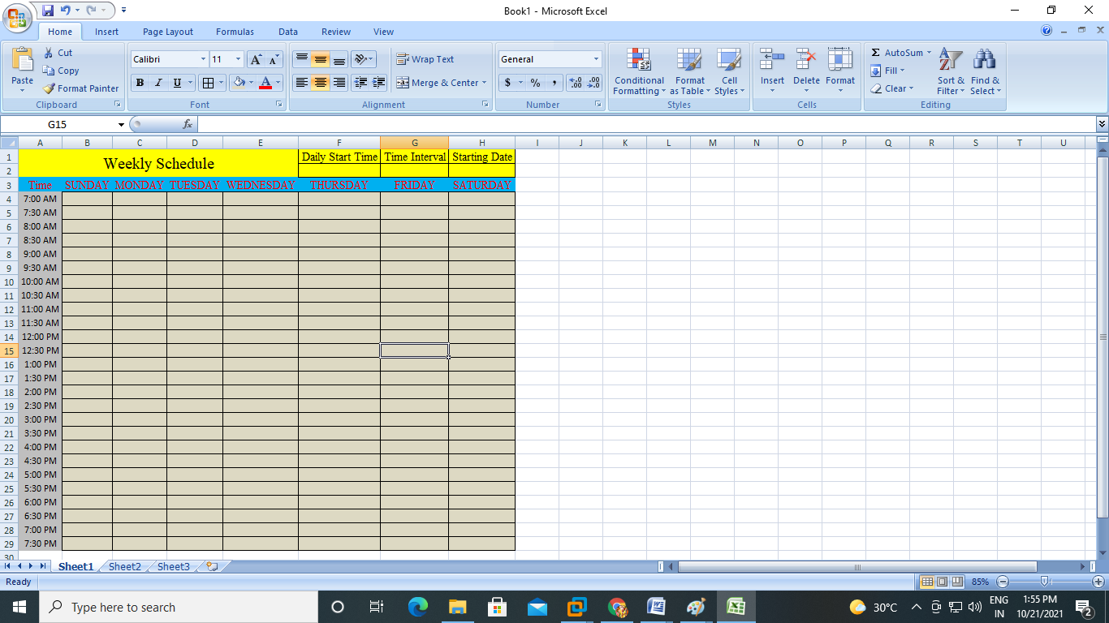

1. Save the schedule.

**Save the Schedule as a Template**

Saving the schedule as a template allows you to reuse it without making a new one each time or clearing the contents of your existing schedule

1. Select **File**> **Export**> **Change File Type**.

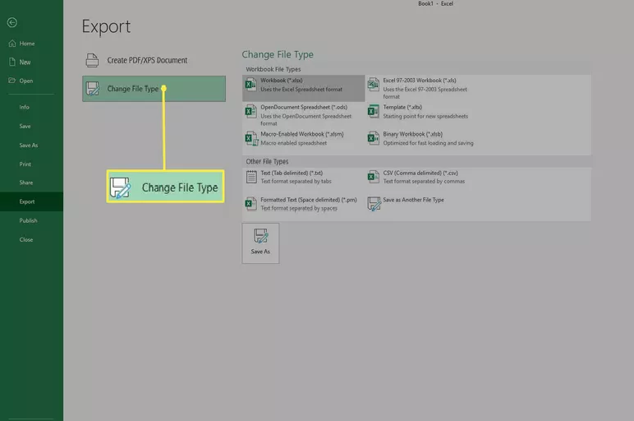

1. Select **Template**> **Save As**. The Save As dialog box will open.

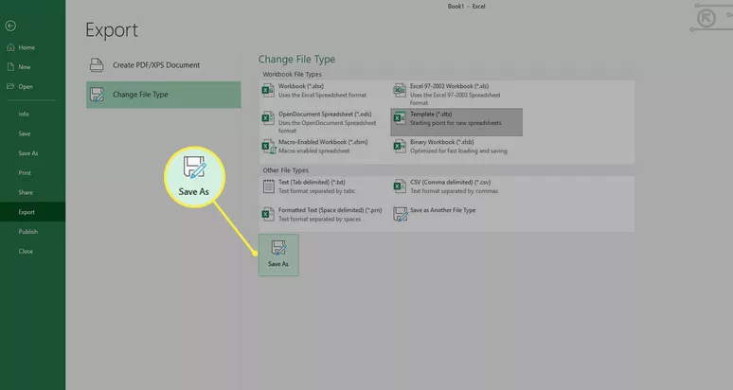

1. Open the **Custom Office Templates**folder.

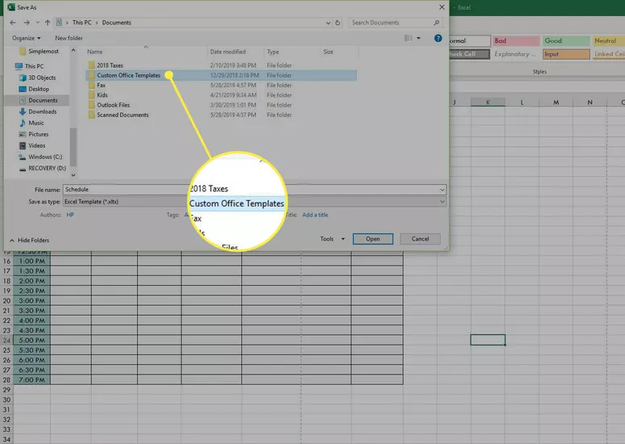

1. Enter a name for the template and select **Save**.

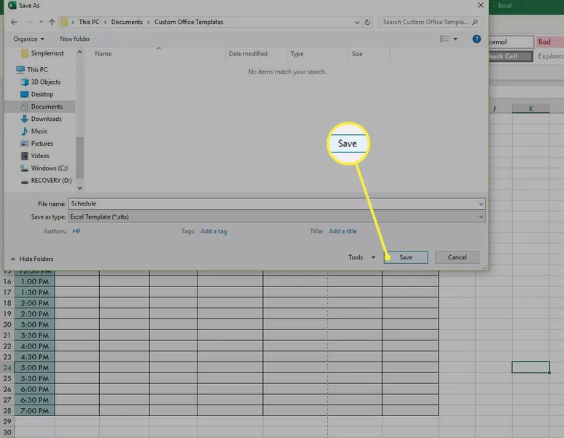

1. To use the template in the future, select the **Personal**tab on the Newscreen and select the schedule template. It will open as a new workbook.

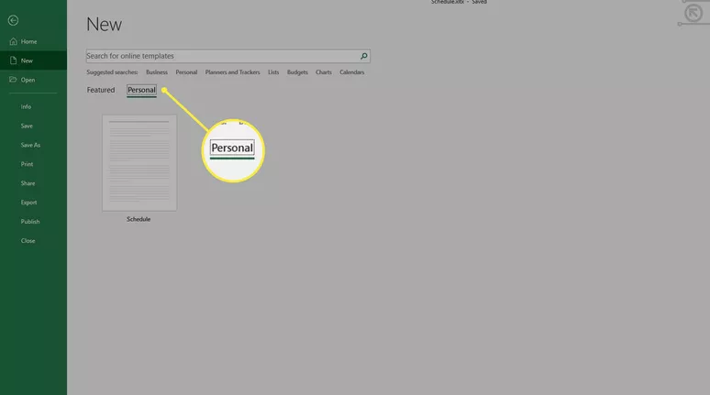

**2. Calculating Grade Point Average (GPA)**

**Step-1:** Create the table in Excel using the following fields.

|  |  |  |  |  |  |  |
| --- | --- | --- | --- | --- | --- | --- |
| S.No | Student name | Subjects | Grade | Credits | Grade Points | Credit Values |

**Step-2:** Fill the five students data in Excel.

|  |  |  |  |  |  |  |
| --- | --- | --- | --- | --- | --- | --- |
| **CALCULATING GPA** | | | | | | |
| S.No | Student name | Subjects | Grade | Credits | Grade Points | Credit Values |
| 1 | Balu | English | A | 3 | 4 | 12 |
| 2 | Vasu | Sanskrit | B | 3 | 3 | 9 |
| 3 | Srinu | Maths | A | 3 | 4 | 12 |
| 4 | Ramesh | Physics | A | 3 | 4 | 12 |
| 5 | Rakesh | Chemsitry | B | 3 | 3 | 9 |

**Step-3:** Calculate the GPA in Excel.

Formula: =sum(d2:d6)/sum(e2:d6)

|  |  |  |  |  |  |  |
| --- | --- | --- | --- | --- | --- | --- |
| **CALCULATING GPA** | | | | | | |
| S.No | Student name | Subjects | Grade | Credits | Grade Points | Credit Values |
| 1 | Balu | English | A | 3 | 4 | 12 |
| 2 | Vasu | Sanskrit | B | 3 | 3 | 9 |
| 3 | Srinu | Maths | A | 3 | 4 | 12 |
| 4 | Ramesh | Physics | A | 3 | 4 | 12 |
| 5 | Rakesh | Chemsitry | B | 3 | 3 | 9 |
|  |  |  |  |  |  |  |
|  |  |  |  |  | GPA | 3.6 |

**3. Student marks list**

**Procedure:**

1. Create a spread sheet with the name “studentmarks.xls”
2. Type the headings like S.No. , student name, subjects, total, rank etc… in appropriate cells. For example S.No. in the cell A1, student name in the cell B1 and soon.
3. Use auto fill function to fill the serial numbers and roll numbers of the student.
4. To use auto fill function we must have to type more than one serial number or roll number.
5. Auto fill function is applicable on numeric values.
6. Apply **format cells,** using this we can select the category of the cell, align the text in the cell, apply font styles, change the font name, size, apply the borders etc…
7. To apply **format cells**, in **home** menu select the option **format** from **cells** option.
8. Apply the auto sum function by selecting the **formula** menu; now choose **auto sum** option in **function library**.
9. To do manual summation type the function “***=sum (number1,[number2], …)***” in **formula bar** in the spread sheet. Example=sum(d2,e2,f2)
10. To sort the cells select those cells to be sorted and choose the **data** menu and select sorting type from **sort &filter**.
11. To draw charts like bar chart, pie chart, etc… choose the **insert** menu and select the type of chart from **charts** option.
12. To place the pictures in the spread sheet choose **insert** menu and select the **picture** option from **illustrations** option.
13. Finally save the spreadsheet.

Example for the student to understand: (**student marks list**)

|  |  |  |  |  |  |  |  |  |  |
| --- | --- | --- | --- | --- | --- | --- | --- | --- | --- |
| S.No | Student name | English | Sanskrit | Maths | Physics | Chemistry | Total | Average | Rank |
| 1 | Balu | 70 | 80 | 80 | 60 | 70 | 360 | 72 | 2 |
| 2 | Vasu | 50 | 60 | 70 | 80 | 90 | 350 | 70 | 3 |
| 3 | Srinu | 80 | 80 | 90 | 90 | 70 | 410 | 82 | 1 |
| 4 | Ramesh | 50 | 45 | 35 | 20 | 20 | 170 | 34 | 5 |
| 5 | Rakesh | 50 | 60 | 70 | 55 | 90 | 325 | 65 | 4 |

**TASK-10**

**Demonstration and Practice of various features Microsoft Power Point**

**Introduction to Ms-Power Point**

A PowerPoint presentation is a presentation created using Microsoft PowerPoint software. The presentation is a collection of individual slides that contain information on a topic. PowerPoint presentations are commonly used in business meetings and for training and educational purposes. Microsoft PowerPoint is a software product used to perform computer based presentations. There are various circumstances in which a presentation is made: teaching a class, introducing a product to sell, explaining an organizational structure, etc. The preparation and the actual delivery of each are quite different. PowerPoint typically comes with a set of preloaded themes for you to choose from. These can range from simple color changes to complete format layouts with accompanying font text. Themes can be applied through the whole presentation or a single slide. Using the page setup allows you to optimize the presentation for the display size; for instance, you should use a larger screen ratio when displaying on a projector compared to a computer screen.

**Features**

PowerPoint software features and formatting options include a wizard that walks you through the presentation creation process. Design templates---prepackaged background designs and font styles that will be applied to all slides in a presentation. When viewing a presentation, slide progression can be manual, using the computer mouse or keyboard to progress to the next slide, or slides can be set up to progress after a specified length of time. Slide introductions and transitions can be added to the slides.

To begin Microsoft PowerPoint, go to Macintosh HD > Applications > Microsoft PowerPoint. Select PowerPoint Presentation from the Project Gallery if a blank document does not open.



**2. Saving**

Computers crash and documents are lost all the time, so it is best to save often. Saving Initially Before you begin to type, you should save your document. To do this, go to File > Save As. Microsoft PowerPoint will open a dialog box. where you can specify the new file’s name and location where you want it saved. Once you have specified a name and a place for your new file, press the Save button. By default, the format for PowerPoint 2013 is .pptx



3. **Ribbons**

Microsoft PowerPoint uses several tabs to allow you to modify your document. When you first open PowerPoint, usually the tabs discussed below will open. If you do not see these tabs, go to View > Ribbon.

The Menu bar: This is constructed solely of word commands and not icons (pictures). The Menu bar contains all the options available to you in Microsoft PowerPoint.



On the Ribbon under the Home Tab, contains a text editor and the new slide icon. The Home Tab contains icons such as Paste, Cut, Copy, Format and Layout



The Insert Tab on the Ribbon toolbar, contains several categories for formatting the design and elements of your presentation. These include: New Slide, Table, Charts, and Word Art.



**4. Home Tab**

New Slide to add an additional new slide to your presentation go to the Home Tab > New Slide. Click the drop down arrow and choose the style of slide you would like to apply.

**Slide Layout**

To apply a Slide Layout, select the Home Tab > Layout to customize the layout of your document. From here, you can specify how the content on your slide is displayed. To apply a layout to your slide click the layout button, and choose your preferred style.



**Insert Tab**

Pictures To insert a picture into your presentation select Insert > Picture. Choose either to get the photo from a browser, or from a file and then locate the image that you want to put into your document and click Insert.



Inserting Slides from a Previously Created File: To insert a slide from another presentation go to Insert > Slides From > Other Presentation and select the directory or disk where the file is located Select the slide that you wish to insert into your presentation.

**Creating a Table**

To create a table within your document, go to the Insert > Table. Choose the desired table size by typing in the required number of rows and columns and click Ok. The table will be inserted into document. To navigate within your table, use the arrow keys.

**Flowcharts**

Flowcharts are used to create diagrams in Microsoft PowerPoint.

To insert a Flowchart in PowerPoint: click Insert Tab > SmartArt. Once the SmartArt button is expanded, you will have several options to choose from, such as List, Process, Hierarchy, etc. To insert Shapes, click the Insert Tab > Shapes. SmartArt Shapes will allow you to manipulate the shapes in Flowchart, as well as in text boxes. To resize the Shapes, simply click and drag any of the four corners on the object.





**Design**

The default slide design for Microsoft PowerPoint documents is a blank slide. Therefore, if you want your slides to have a specific design, you must add one. To do this on a Mac, go to the Design Tab. To change the theme of your presentation, click on the theme that you like and it will automatically apply to your slide.



**Transition**

Adding Transitions Inbetween Slides To add a Transition into your presentation select the Transitions Tab. You are then given a variety to choose from. i.e., “Fade”. 

**Duration**

Along the right hand side of the Transitions options you will see Duration. This allows you to modify the Duration of the Transition that is present on the particular slide. This also features an ability to play a sound and to control whether or not to change to the next slide by “On Mouse Click”.



**TASK-11**

**Demonstration and Practice of various features LaTeX – document preparation, presentation**

**Importance of latex:**

LaTeX is a TeX format written by a computer scientist named Leslie Lamport. LaTeX is based on the principle that authors should concentrate on logical design rather than visual design when writing their documents. Thus instead of writing

\vspace{1.5cm}

\begin{centering}

\Large \bf

2. Section Title

\end{centering}

What about spell checking? It's a good point. This is not a deficiency of LaTeX, because it just processes the words you give it. However, within your text-editor, you do not get fancy lines highlighting your spelling errors or bad grammar as you type, like you get with Word, yet it's a feature users have come to expect when writing documents.

Overview of toolbars, saving files and using help and resources:

Latex Toolbar with menu bar:

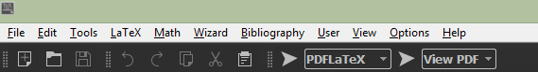

Latex toolbar contains the following options:

* New
* Open
* Save
* Undo
* Redo
* Cut
* Copy
* Find
* Replace

**Creating a document in LaTeX**

LATEX is a great tool to create documents. It's based on the 'WYSIWYM' (what you see is what you mean) idea, meaning you only have to focus on the contents of your document and the computer will take care of the formatting. With LATEX, it's very easy to create professional-looking material. This article presents the basics of how to create a document.

1. Introduction
2. The preamble of a document
3. Displaying the title of your document
4. Basic formatting: abstract, paragraphs and newlines
5. Comments

**Introduction**

Let's start with the simplest working example:

\documentclass{article}

\begin{document}

First document. This is a simple example, with no

extra parameters or packages included.

\end{document}

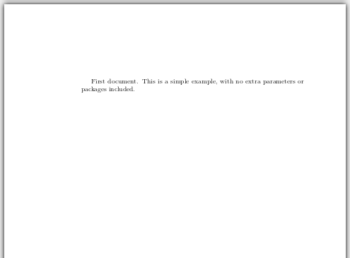

The input file is just a plain text file, with the extension .tex. It will contain code that the computer interprets to produce a PDF file. The first line of code declares the type of document, in this case is an *article*. Then, between the \begin{document} \end{document} tags you must write the text of your document.

**The preamble of a document**

In the previous example the text was entered after the \begin{document} command. The part of your .tex file before this point is called the preamble. In the preamble, you define the type of document you are writing and the language, load extra packages you will need, and set several parameters. For instance, a normal document preamble would look like this:

\documentclass[12pt, letterpaper]{article}

\usepackage[utf8]{inputenc}

\title{First document}

\author{Hubert Farnsworth \thanks{funded by the Overleaf team}}

\date{February 2014}

Below a detailed description of each line:

**\documentclass[12pt, letterpaper]{article}**

As said before, this defines the type of document. Some additional parameters inside brackets and comma-separated can be passed to the command. In the example, the extra parameters set the font size (12pt) and the paper size (letterpaper). Of course other font sizes (9pt, 11pt, 12pt) can be used, the default size is 10pt. As for the paper size, other possible values are included A4 and legalpaper. Note that Overleaf uses a European LaTeX distribution, which produces documents in A4 size by default. See our [Page size and margins]] article for for information about using the Geometry package to set further formatting parameters.

**\usepackage[utf8]{inputenc}**

This is the encoding for the document, to allow characters beyond ASCII (e.g. à, ü, č ...) to be used in the text. It can be omitted or changed to another encoding but utf-8 is recommended. Unless you specifically need another encoding, or if you are unsure about it, add this line to the preamble.

The next three lines are self-descriptive. Anyway, you can see a description of what they actually do in the next section.

Another important parameter that can be passed to the \document class command is two column if you want your text in a two-column format and two side for two-side paper sheet printing.

**Displaying the title of your document**

To display the title of your document you have to declare its components in the [preamble](https://www.overleaf.com/learn/latex/Creating_a_document_in_LaTeX#The_preamble_of_a_document) and then use some additional code:

\documentclass[12pt, letterpaper, twoside]{article}

\usepackage[utf8]{inputenc}

\title{First document}

\author{Hubert Farnsworth \thanks{funded by the Overleaf team}}

\date{February 2014}

\begin{document}

\begin{titlepage}

\maketitle

\end{titlepage}

In this document some extra packages and parameters

were added. There is an encoding package

andpagesize and fontsize parameters.

\end{document}

There is a block with three lines in the preamble that defines the information to be included on the title page.

\title{First document}

This is the title.

\author{Hubert Farnsworth}

Here you put the name(s) of the author(s) and, as an optional parameter, you can add the next command:

\thanks{funded by the Overleaf team}

This can be added after the name of the author, inside the braces of the title command. It will add a superscript and a footnote with the text inside the braces. Useful if you need to thank an institution in your article.

\date{February 2014}

You can enter the date manually or use the command \today so the date will be updated automatically at the time you compile your document.

Once you have that in the preamble now in the body of your document you can use the next commands for the information to be printed.

\begin{titlepage} \end{titlepage}

This declares an environment, a block of code with a specific behaviour depending on its type. In this case whatever you include in this *titlepage* environment will appear in the first page of your document.

\maketitle

This command will print the title, the author and the date in the format shown in the example. If it's not enclosed in a *titlepage* environment, it will be shown at the beginning of the document, above the first line.

**Basic formatting: abstract, paragraphs and newlines**

Everything included inside the \begin{document} \end{document} commands will be rendered in the final document.

\documentclass[12pt, letterpaper, twoside]{article}

\usepackage[utf8]{inputenc}

\begin{document}

\begin{abstract}

This is a simple paragraph at the beginning of the document. A brief introduction to the main subject.

\end{abstract}

In this document some extra packages and parameters

were added. There is an encoding package,

andpagesize and fontsize parameters.

This line will start a second paragraph. And I can

break\\ the lines \\ and continue on a new line.

\end{document}

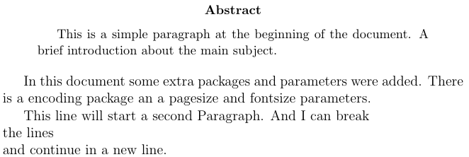

In scientific documents, it's a common practice to include a brief overview of the main subject of the paper. In LATEX, the *abstract* environment is for this purpose. The *abstract* environment will put the text in a special format at the top of your document.

When writing the contents of your document, if you need to start a new paragraph you must hit the "Enter" key twice (to insert a double blank line). Notice that paragraphs have a white space before the first line.

To start a new line without actually starting a new paragraph insert a *break line* point, this can be done by \\ (a double backslash as in the example) or the \newline command

**Comments**

Sometimes it's necessary to add comments to your LATEX code for readability. This is straightforward, put a % before the comment and LATEX will ignore that text.

\documentclass{article}

\usepackage[utf8]{inputenc}%codification of the document

\usepackage{comment}

%Here begins the body of the document

\begin{document}

This document contains a lot of comments, none of them

will appear here, only this text.

This document contains a lot of comments, none of them

will appear here, only this text.

\begin{comment}

This text won't show up in the compiled pdf

this is just a multi-line comment. Useful

to, for instance, comment out slow-rendering parts

while working on a draft.

\end{comment}

\end{document}

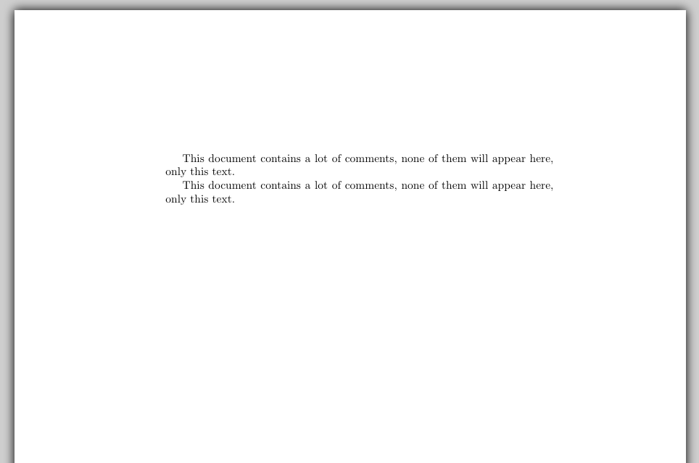

In the last part of the example, you can see a *comment* environment. This helps in multi-line comments instead of putting a % at the beginning of each line. For this to work you must add the next line to your preamble:

\usepackage{comment}

**TASK-12**

**Tools for converting WORD to PDF and PDF to WORD**

Portable Document Format commonly known as PDF was invented with the intention of making the sharing of documents and files across multiple devices easier.

The idea was to create an immaculate, compact version of the original file that would be difficult to tamper with during its transition from one device to another. This is one purpose that it has accomplished with great success.

**Step- 1:** Navigate to [ilovepdf.com](https://www.ilovepdf.com/)

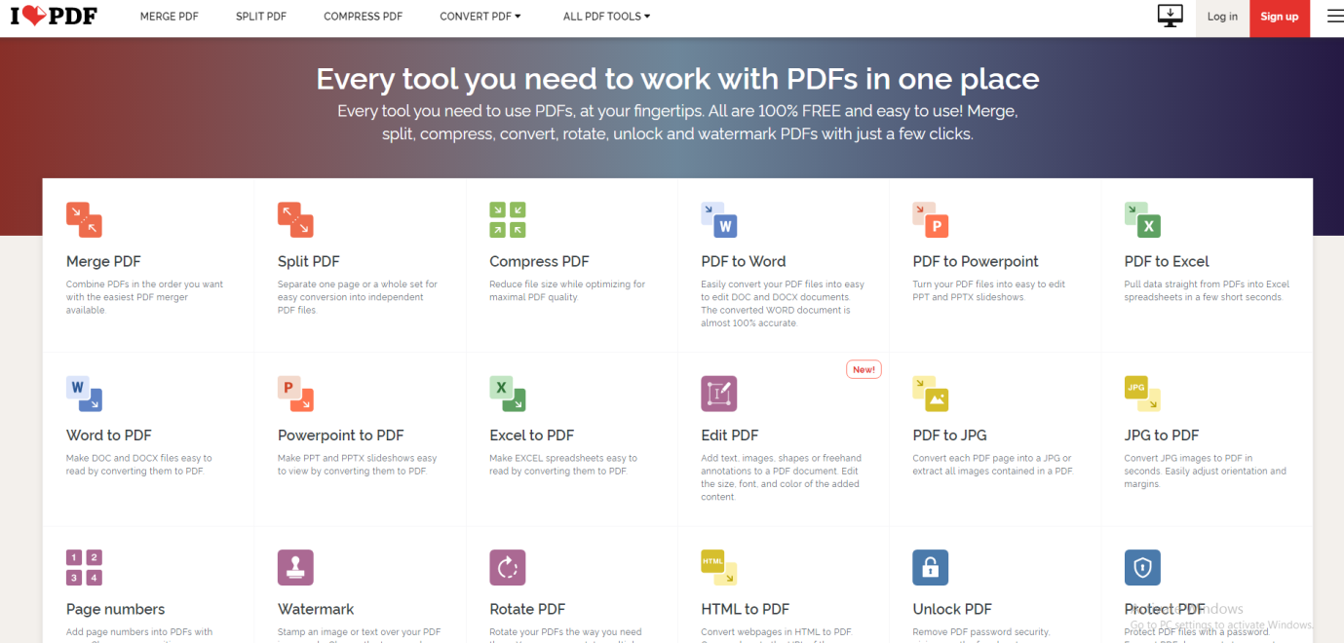

**Step-2:** Click on **Word to PDF** icon

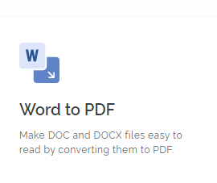

**Step-3:** click on Select WORD files button

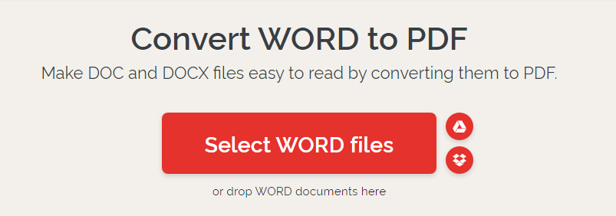

**Step-4:** Select file from local Drive and Click on **Convert to PDF** button.

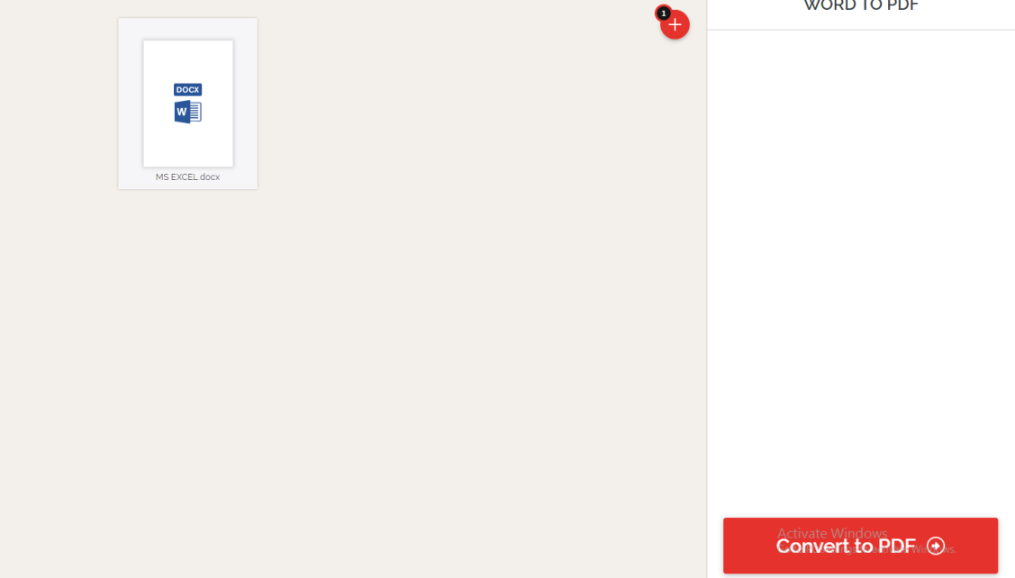

**Step-5:** Click on **Download PDF** button

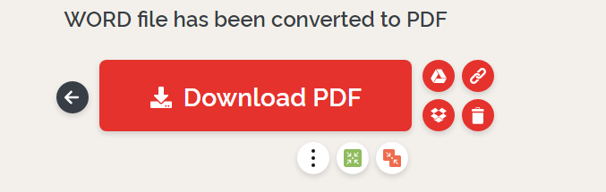

**TASK-13**

**Internet of Things**

**IoT (Internet of Things):**

IoT tutorial provides basic and advanced concepts of IoT. Our Internet of Things tutorial is designed for beginners and professionals.

IoT stands for Internet of Things, which means accessing and controlling daily usable equipments and devices using Internet.

Our IoT tutorial includes all topics of IoT such as introduction, features, advantage and disadvantage, ecosystem, decision framework, architecture and domains, biometric, security camera and door unlock system, devices, etc.

**What is an Internet of Things (IoT)**

Let's us look closely at our mobile device which contains GPS Tracking, Mobile Gyroscope, Adaptive brightness, Voice detection, Face detection etc. These components have their own individual features, but what about if these all communicate with each other to provide a better environment? For example, the phone brightness is adjusted based on my GPS location or my direction.

Connecting everyday things embedded with electronics, software, and sensors to internet enabling to collect and exchange data without human interaction called as the Internet of Things (IoT).

The term "Things" in the Internet of Things refers to anything and everything in day to day life which is accessed or connected through the internet.

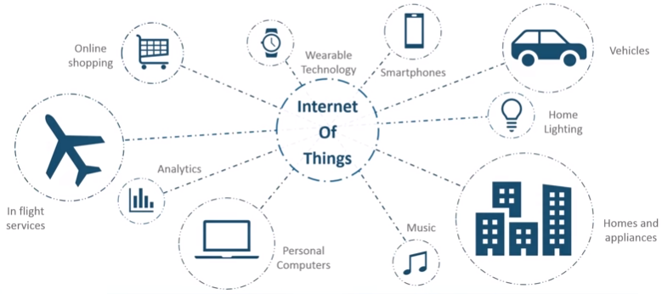

IoT is an advanced automation and analytics system which deals with artificial intelligence, sensor, networking, electronic, cloud messaging etc. to deliver complete systems for the product or services. The system created by IoT has greater transparency, control, and performance.

As we have a platform such as a cloud that contains all the data through which we connect all the things around us. For example, a house, where we can connect our home appliances such as air conditioner, light, etc. through each other and all these things are managed at the same platform. Since we have a platform, we can connect our car, track its fuel meter, speed level, and also track the location of the car.

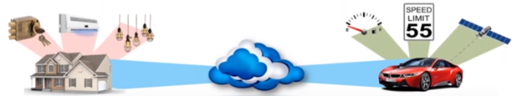

If there is a common platform where all these things can connect to each other would be great because based on my preference, I can set the room temperature. For example, if I love the room temperature to to be set at 25 or 26-degree Celsius when I reach back home from my office, then according to my car location, my AC would start before 10 minutes I arrive at home. This can be done through the Internet of Things (IoT).

**How does Internet of Thing (IoT) Work?**

The working of IoT is different for different IoT echo system (architecture). However, the key concept of there working are similar. The entire working process of IoT starts with the device themselves, such as smartphones, digital watches, electronic appliances, which securely communicate with the IoT platform. The platforms collect and analyze the data from all multiple devices and platforms and transfer the most valuable data with applications to devices.

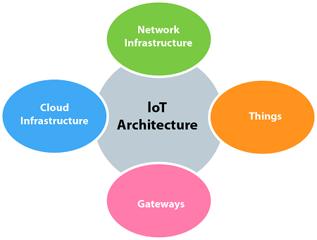

**Features of IOT**

The most important features of IoT on which it works are connectivity, analyzing, integrating, active engagement, and many more. Some of them are listed below:

**Connectivity:**

Connectivity refers to establish a proper connection between all the things of IoT to IoT platform it may be server or cloud. After connecting the IoT devices, it needs a high speed messaging between the devices and cloud to enable reliable, secure and bi-directional communication.

**Analyzing:**

After connecting all the relevant things, it comes to real-time analyzing the data collected and use them to build effective business intelligence. If we have a good insight into data gathered from all these things, then we call our system has a smart system.

**Integrating:**

IoT integrating the various models to improve the user experience as well.

**Artificial Intelligence:**

 IoT makes things smart and enhances life through the use of data. For example, if we have a coffee machine whose beans have going to end, then the coffee machine itself order the coffee beans of your choice from the retailer.

**Sensing:**

The sensor devices used in IoT technologies detect and measure any change in the environment and report on their status. IoT technology brings passive networks to active networks. Without sensors, there could not hold an effective or true IoT environment.

**Active Engagement:**

IoT makes the connected technology, product, or services to active engagement between each other.

**Endpoint Management:**

 It is important to be the endpoint management of all the IoT system otherwise, it makes the complete failure of the system. For example, if a coffee machine itself order the coffee beans when it goes to end but what happens when it orders the beans from a retailer and we are not present at home for a few days, it leads to the failure of the IoT system. So, there must be a need for endpoint management.